**SPRING MICROSERVICES**

Spring boot version – 2.4.5

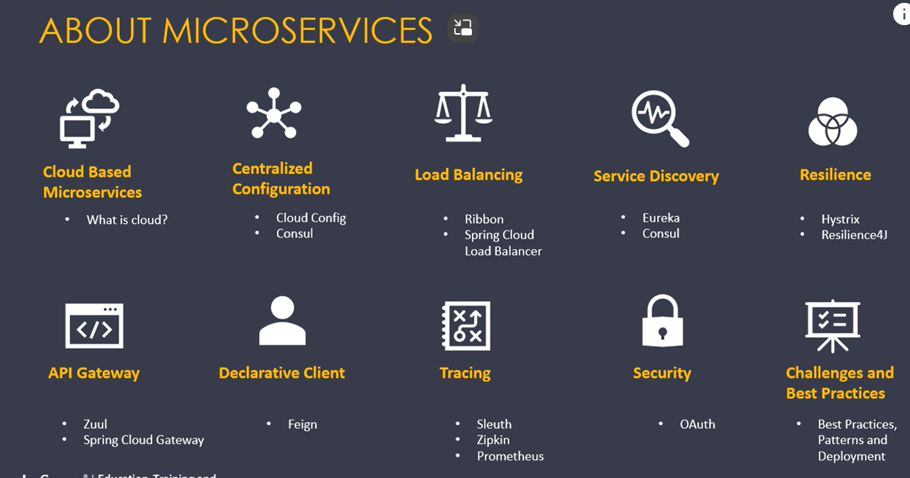

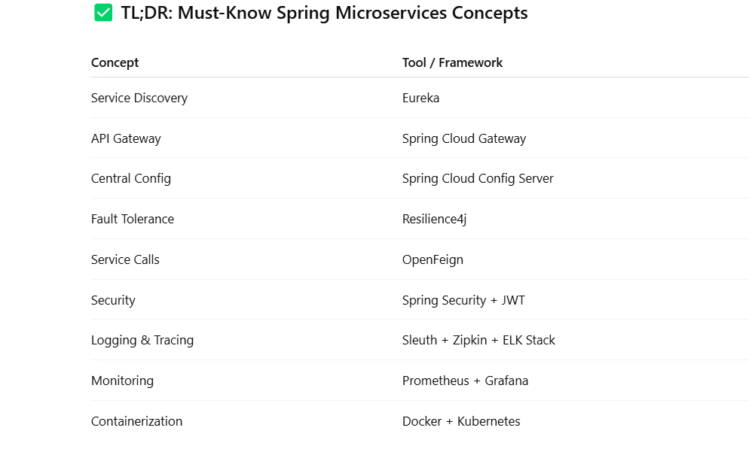

Concepts:

* Split a monolithic application into microservices.
* Store configuration details on cloud using **CloudConfig**
* Load balance requests between microservices using **Ribbon**
* Discover services in cloud using **Eureka**
* Increase resilience through **Hystrix**
* Use asynchronous communication to improve performance
* Create an API gateway using **Zuul**
* Simplify REST calls through **Feign**
* Secure microservices using **OAuth** through Spring Cloud Security
* Monitor your microservices through Turbine, Sleuth, and Zipkin

The Monolithic application was a good solution for the requirements of earlier times.

But with recent needs for better user experience, monolithic applications fail to deliver the following functionalities:

* The entire app must be redeployed for a small change, thus increasing the downtime
* Larger the app, larger deployment time and startup time is required
* If specific parts of the application experience a larger load entire app must be deployed in multiple servers to take care of scaling. This takes the resources and increases maintenance problems
* Large code becomes intimidating
* If later any functionality can be written using python or scala or C#, modification is extremely difficult.

There are alternatives for monolithic architecture, such as Service Oriented Architecture, Microservices, etc.

Microservice is an **architectural** style. In this style, the application is made up of smaller ( or micro ) apps that communicate with each other, through open protocols like HTTP.

Microservices are **distributed** in nature. It can either decompose a monolithic app into a microservice or can develop a microservice-based solution from the beginning.

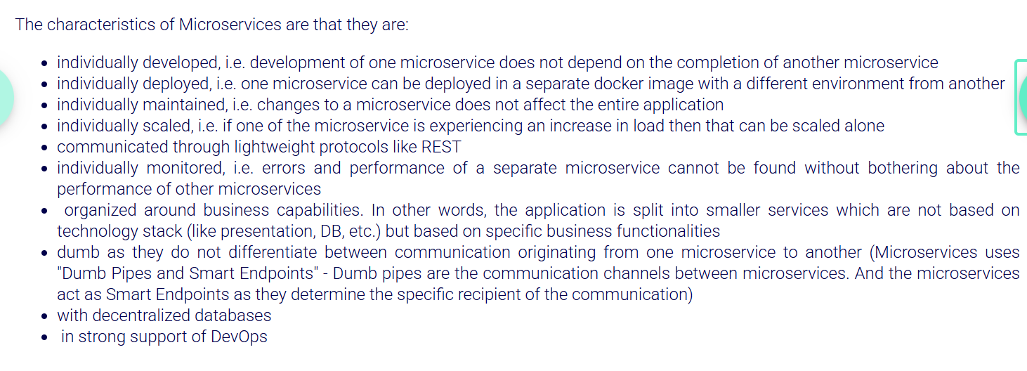

Microservices is a buzzword technology gaining a lot of traction. Based on the **need**, **competence**, and **size** of the applications, one may have to choose between Monolithic, SOA, Microservice, etc.

If monolithic is bad, people would not have been using it.

Monolithic has its advantages (if it’s reasonable in size)* such as:

* easier to get the bigger picture of the application, as the entire code base is in one place
* only one jar/war file must be deployed
* relatively simple and straightforward to develop
* dependency on network latency and security is greatly reduced
* Monolithic applications are deployed as a single file
* Monolithic applications have problems in deployment, scaling, technology, etc
* Microservices is an architectural style in which the bigger single application is broken down into loosely coupled services
* Microservices are individually maintained, deployed, developed, tested
* Microservices intercommunicate using lightweight protocols like REST.
* Each Microservice can use its own set of technologies.

The right approach in dealing with databases in a microservice architecture is:

* Each microservice should have its own set of tables in a separate database or schema
* One microservice should not try to directly access tables owned by another microservice. If there is a data dependency then a microservice should call another service through REST API to fetch data.
* Foreign key constraints should not be there. We can still have columns to establish a link between entities.
* We should not use joins between tables owned by two different microservices. If you need data from both tables to make a database call to fetch data owned by own service and make REST call to fetch data from the other. This pattern is called API Composition.

How to use independent DB for Infytel microservice?

1. Remove foreign key constraints from all the tables
2. All microservices should have only entity classes related to their own functionality alone. Therefore remove other entity classes from the customer microservice
3. Since there are no foreign key constraints and no other entity classes in the microservices, add endpoints in the microservices which will provide relevant data.
4. View Profile endpoint in customer microservice currently fetches data from Friend and Family and the Plan table directly. Now it needs to get these data from other microservices.
5. In Friend and Family microservice, create a new endpoint for fetching friend and family details for a customer
6. In Plan Microservice, create a new endpoint for fetching plan details for a customer
7. Modify View Profile endpoint in Customer Microservice to invoke these two new endpoints for fetching relevant details

Deploying our application on the cloud makes hardware maintenance much easier as it becomes the responsibility of the cloud provider.

Our applications have to be cloud native, in other words, they should be written in such a way that it can make use of the advantages of the cloud ecosystem.

Elasticity, availability, security are some of the features we get by deploying our application in a cloud environment.

* Since the services are deployed at random hosts and ports, how can Customer microservice know where to find the other microservices?
* Most of the configuration details of the 4 microservices are similar. How can we avoid this duplication?
* Since in cloud plan and friend-family are dynamically deployed, how will the customer microservice know where to find them?
* When we scale friend-family in the cloud, how customer service can load balance the load across multiple instances of them?
* What if while fetching the profile the request friend-family service fails. How to bring in resilience?
* Since the application is now spread across as multiple microservices, how do we trace the flow of a request?

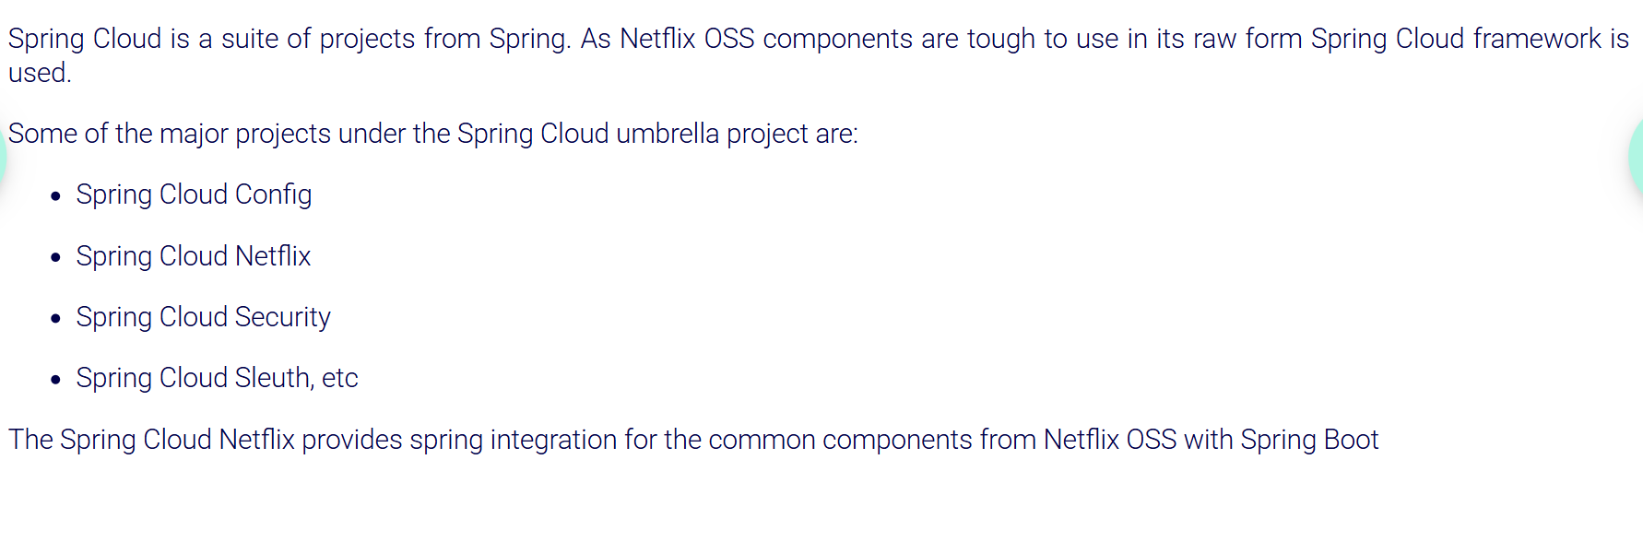

***Application.Properties ::***

**✅ spring.application.name=Infytel**

* **Purpose**: Sets the name of the Spring Boot application.
* **Use**: This name is used in logging, service discovery (in cloud environments like Eureka), and can help identify the application in distributed systems.

**✅ server.port=8000**

* **Purpose**: Specifies the port on which the embedded web server (e.g., Tomcat) runs.
* **Default**: If not set, Spring Boot uses port **8080**.
* **Effect**: Your application will be accessible at http://localhost:8000.

**✅ spring.datasource.url=jdbc:mysql://localhost/infytel**

* **Purpose**: URL to connect to the MySQL database.
* jdbc:mysql:// → This specifies the **JDBC protocol** for MySQL.
* localhost: The MySQL server is running on the **local machine**
* /infytel: This is the **database name** that Spring Boot will connect to.

**✅ spring.datasource.username=root**

* **Purpose**: The **username** used to connect to the MySQL database.
* **"root"** is the default MySQL admin user (not recommended for production).

**✅ spring.datasource.password=root**

* **Purpose**: The **password** for the database user.
* Be cautious about hardcoding sensitive data like this (especially in version-controlled files).

**In entity class:**

**In Simple Terms:**

* @Column(nullable = false) → **This field is required** (you must provide a value for it).
* @Column(nullable = true) (default) → The column can be NULL.

**✅ What nullable = false Means:**

It tells JPA (and Hibernate) that the **plan_id column in the database must not allow NULL values**.

So, when Hibernate generates the table, it will translate this into:

plan_id CHAR NOT NULL

***Eureka Server :***

The **Eureka Server** is a **dedicated central server** whose only job is to act as a **service registry** that maintains a list of all available service instances.

All your other microservices (clients) **register themselves** to this server and **discover** each other through it.

**@EnableEurekaServer**

* This annotation is used **only on the Eureka Server** application — the **service registry**. This is where microservices **register** themselves and **discover** other services.

• ✅ Create a new project for Eureka✔️

• ✅ Add Eureka server dependency, web dependency in pom.xml✔️

• ✅ @EnableEurekaServer on top of main class✔️

• ✅ Add config in application.yml (port no., application name, url)✔️

• ✅That’s it service registry is ready

**@EnableEurekaClient**

For your other microservices (clients), you use **@EnableEurekaClient** or **just the Spring Cloud dependencies** (in newer versions, the annotation is optional) and configuration in **application.yml** file to locate eureka for registration and to discover other services.

Means microservices (the **Eureka clients**) need to be configured to know where the **Eureka Server** is located, so they can register themselves and discover other services.

This is done by specifying the **Eureka Server's URL** in the **configuration file** of the microservices (either in application.properties or application.yml).

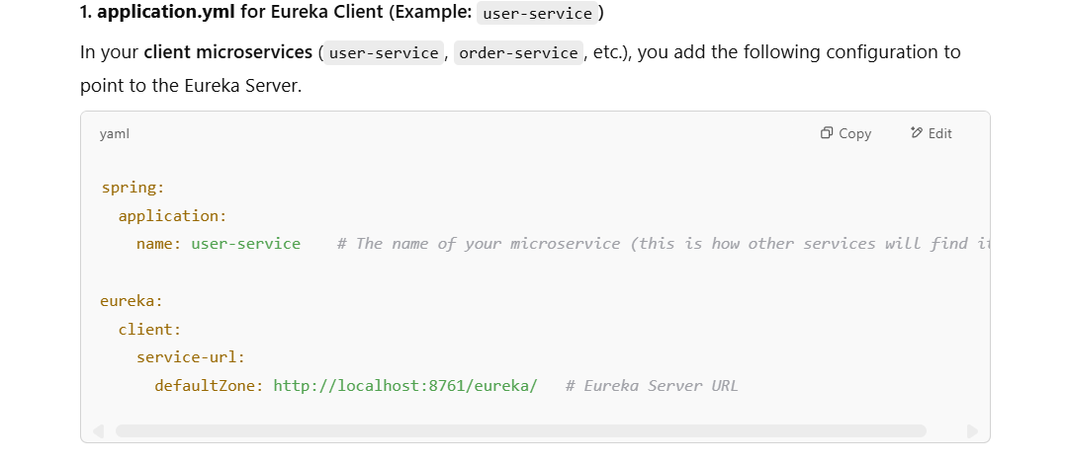

• **spring.application.name**: This is the **name of the microservice** that will be registered with Eureka. For example, user-service.

• **eureka.client.service-url.defaultZone**: This is the URL of your **Eureka Server** where your microservices will **register themselves**. In this case, the server is running on http://localhost:8761/eureka/. The default port for Eureka is usually **8761**, but this can vary depending on your setup.

**Load Balancing (Ribbon / Spring Cloud LoadBalancer)**

Focuses on distributing incoming requests across multiple **instances** of the same service.

* Example: If you have 5 instances of a user-service, a load balancer might send requests to them evenly to prevent any instance from becoming overloaded.
* Common tools: **Nginx**, **HAProxy**, or cloud services like AWS ELB (Elastic Load Balancer).

***Config Server*** (Centralized Configuration)

A **Config Server** is a **centralized configuration service** for your microservices.

Instead of writing configuration (application.yml or application.properties) separately in every microservice, you can store **all your configs in one place** — usually in a **Git repository** — and all your microservices **read from it** at startup.

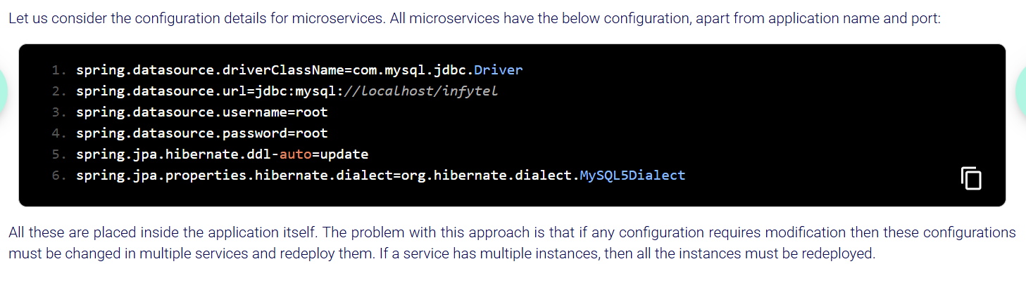

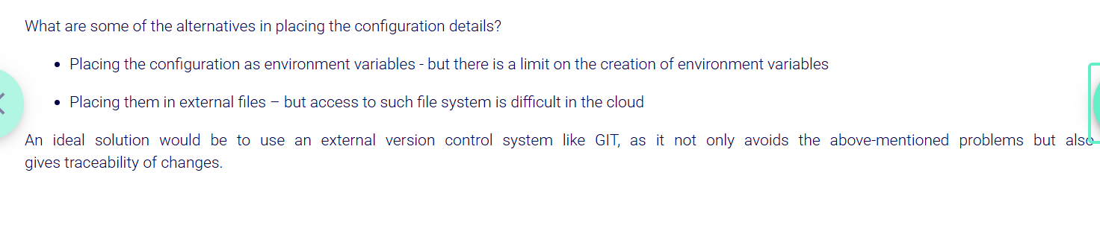

Config server doesn’t store config files instead it is just a **bridge** between microservices and the config repo. Config Server fetches .yml files for microservices from the Git repo.

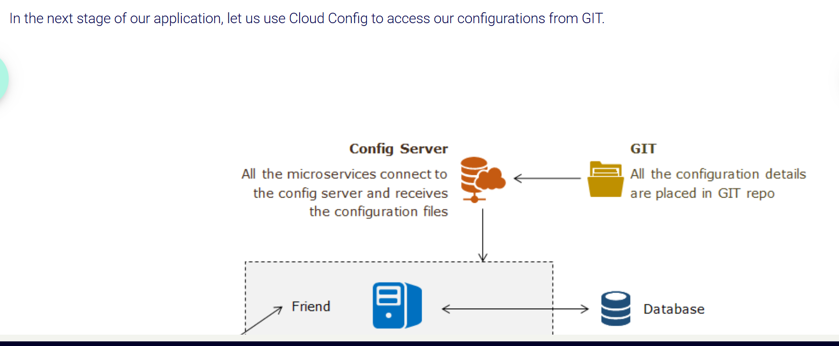

✅ Create a **new Spring Boot project** called **config-server** and add **spring-cloud-config-server** dependency and **spring-cloud-dependencies**.

✅Add **@EnableConfigServer** annotation on main class of this config server project.

✅ Store all configs in a **Git repo** (or local folder)

✅Configure Git Repository in application.yml so that config server gets the files from git.

✅ Each microservice should include the **spring-cloud-starter-config** dependency and point to the Config Server for the configuration files.

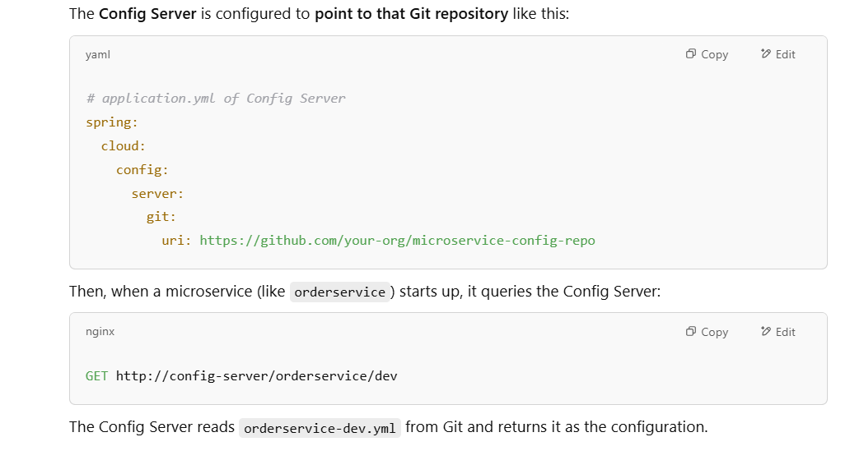

**STEPS:::**

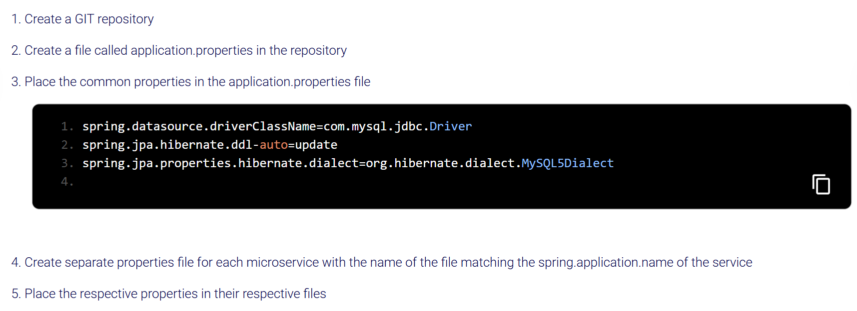

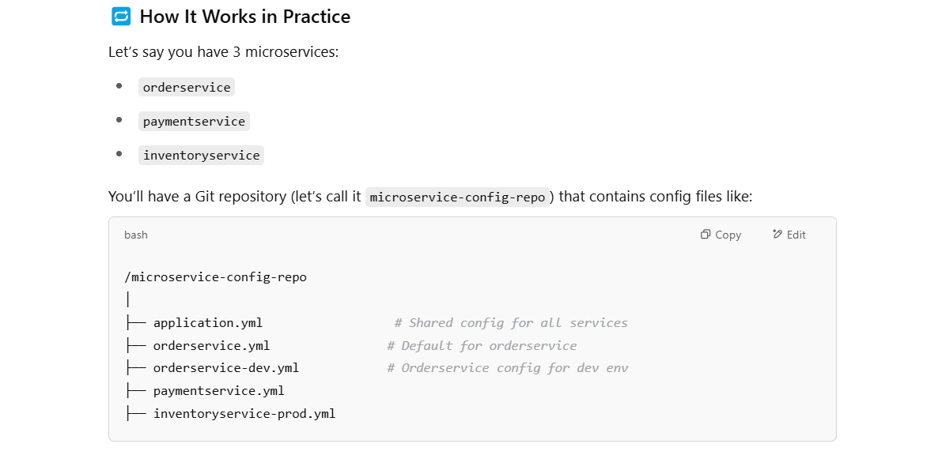

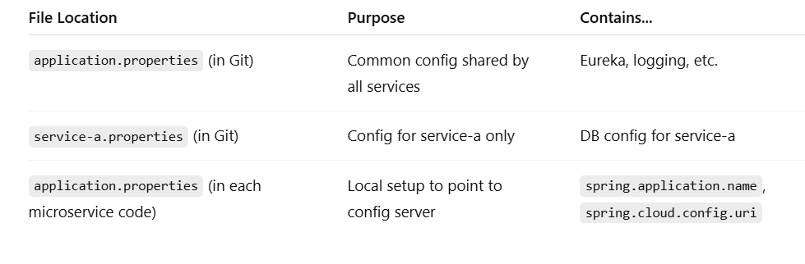

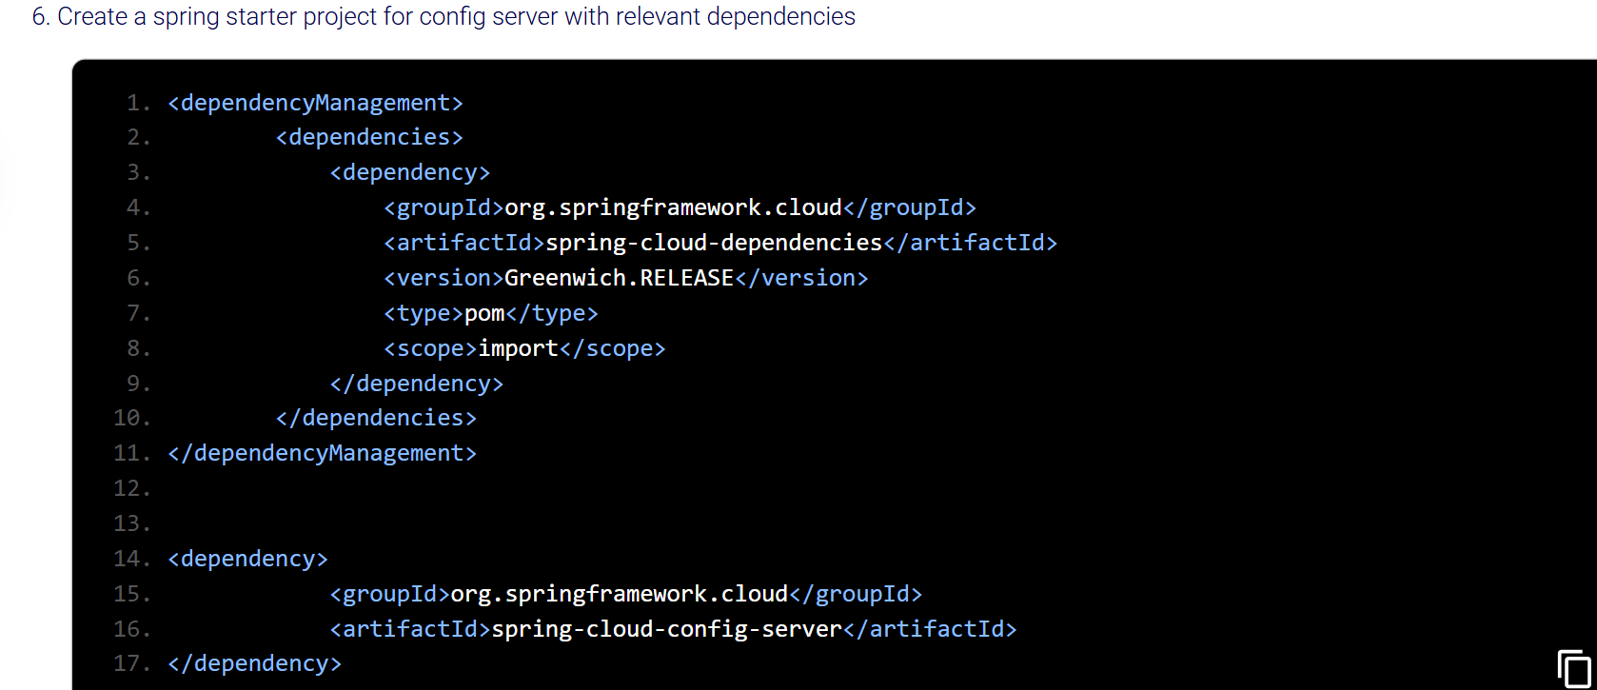

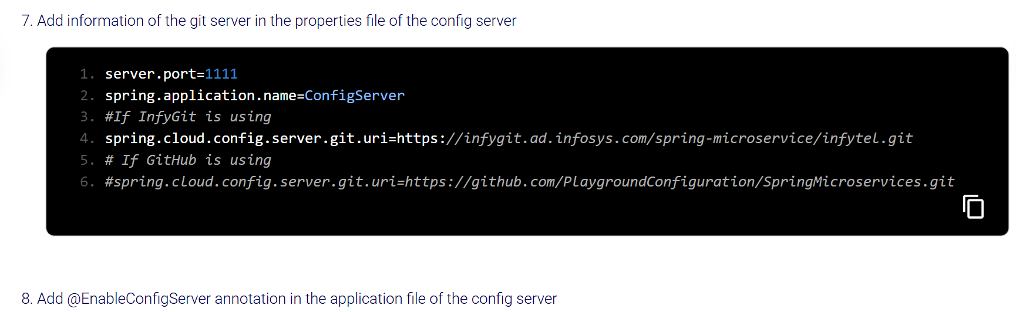

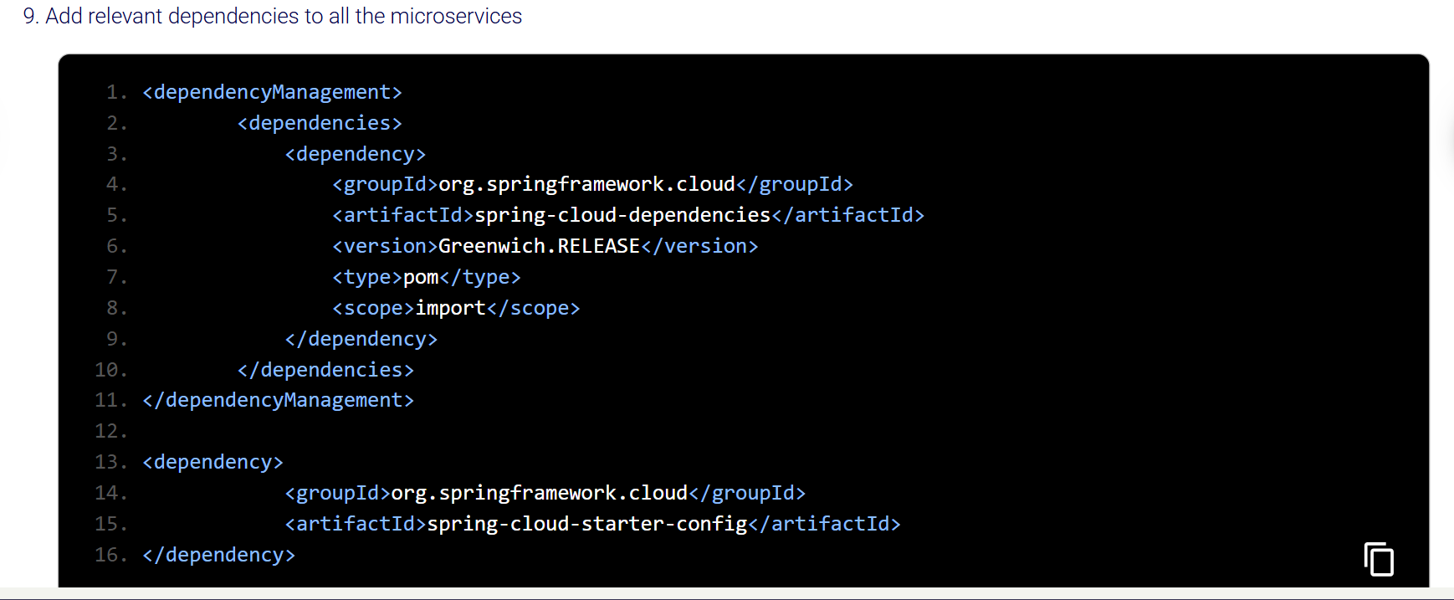

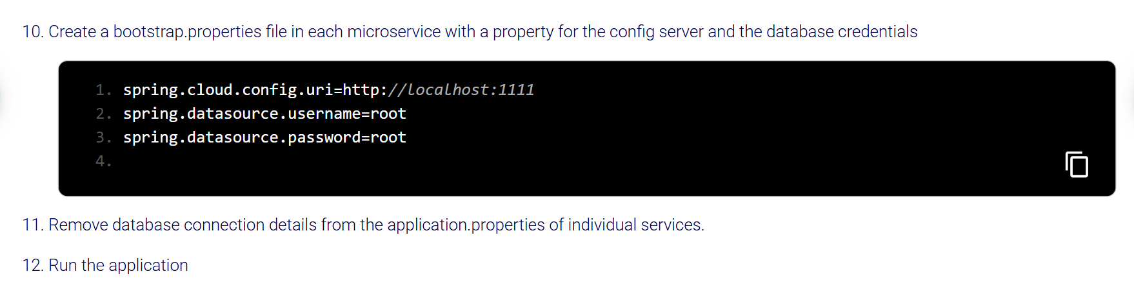

Notes :

**Yes — if your microservices use Spring Cloud Config Server** then:

* **The Config Server must be running before any microservice** that tries to pull configuration from it.
* Otherwise, the microservices will fail to start because they can't load their configuration.
* **bootstrap.yml** or **bootstrap.properties runs** before **application.yml** in a Spring Boot application. So we place the spring.cloud.config.uri things of config in bootstrap only of each microservice.

**🔄 How Spring Cloud Config Server fetches latest config:**

**1. On Demand — per request**

When a microservice restarts (or hits /actuator/refresh), the **Config Server**:

* **Fetches the latest files from Git** at that moment.
* Unless caching is configured, it **pulls fresh data from Git every time a client requests config.**

So even **without restarting** the Config Server, it will:

* Pull the latest version of the config when your microservice restarts and calls the Config Server during bootstrap.

✅ **Yes — the profile part (default or another) is required** in the Spring Cloud Config Server URL.

**🔹 Why is it required?**

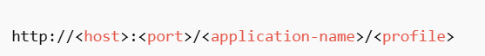

Spring Cloud Config is designed to serve configurations based on two key identifiers:

/{application-name}/{profile}

So, **even if you don't actively use multiple profiles**, the **profile segment must still be in the URL** — and default is used as the fallback when no specific profile like dev or prod is active.

So in http://localhost:4000/application/default:

* application = the name of the application whose config you want (i.e., application.yml).
* default = the profile you’re asking for (like dev, prod, or here default).

Eg:

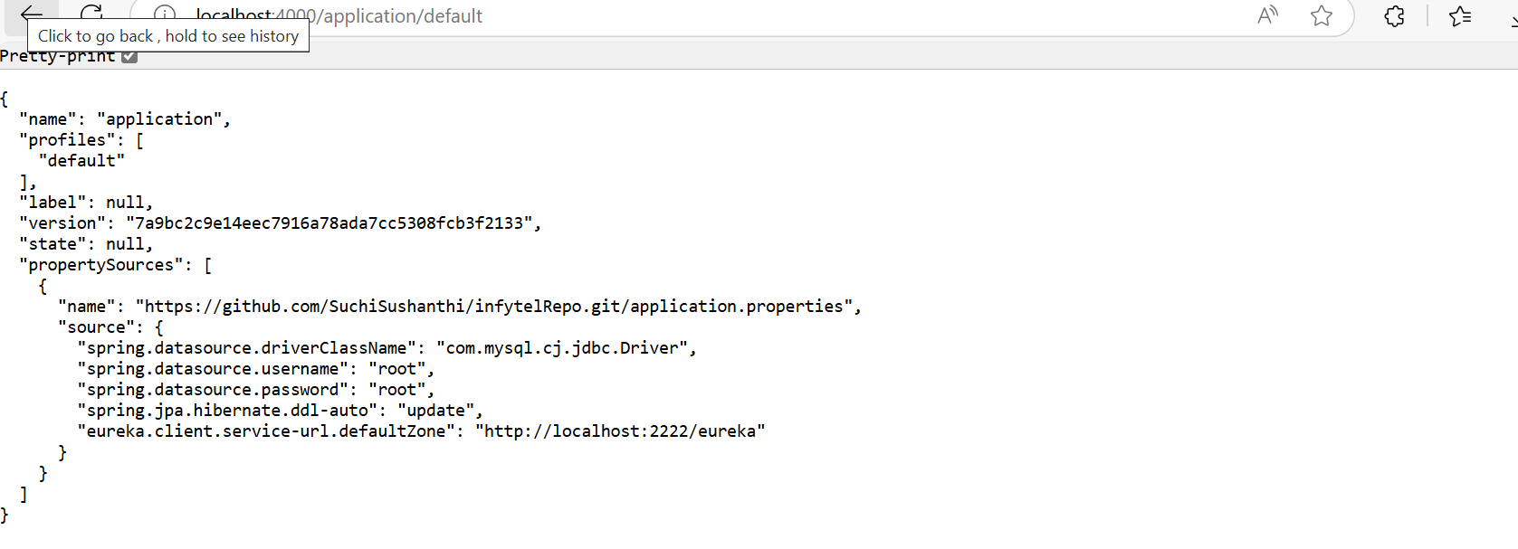

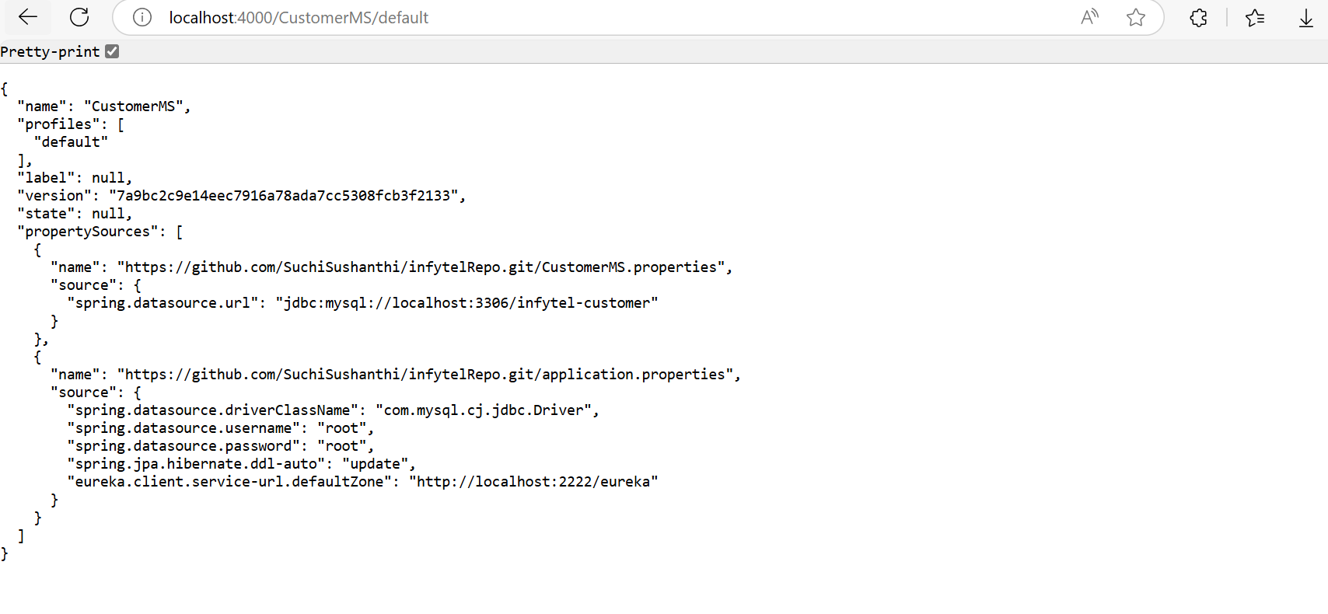

When your CustomerMS microservice boots up and connects to the config server, it **gets a merged config** of:

* Base configs from application.properties
* Overridden or additional settings from CustomerMS.properties

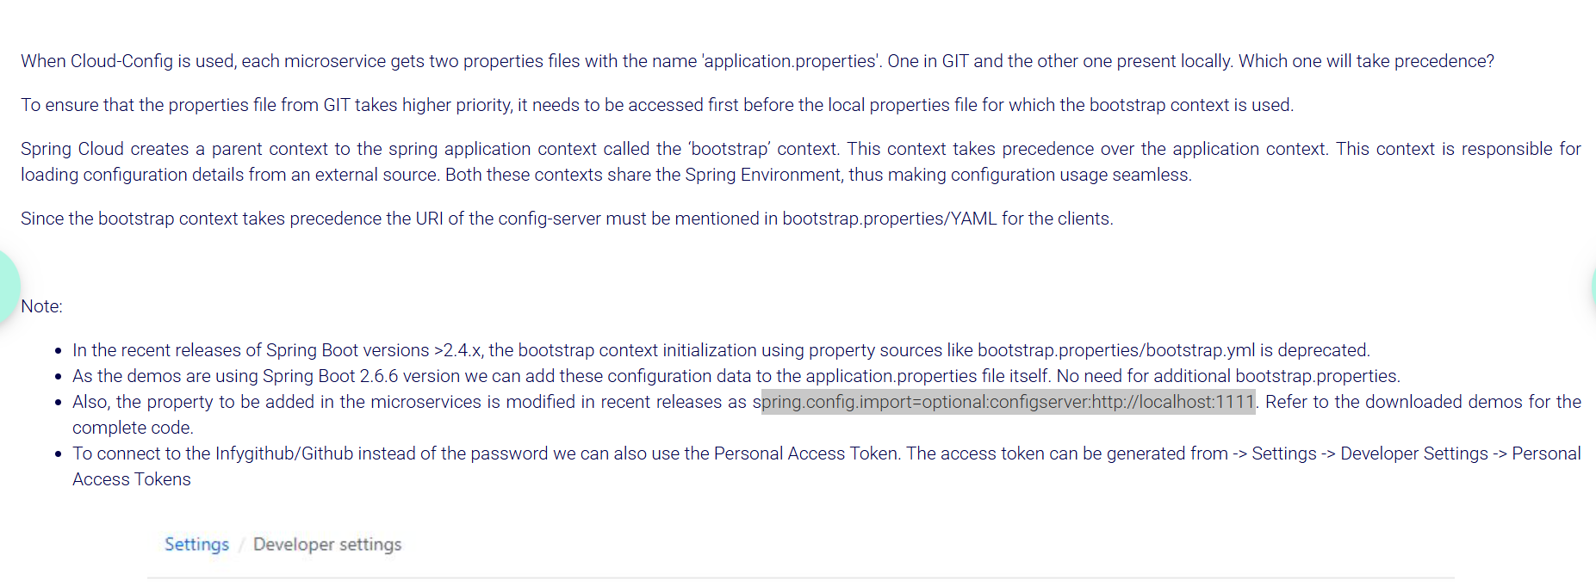

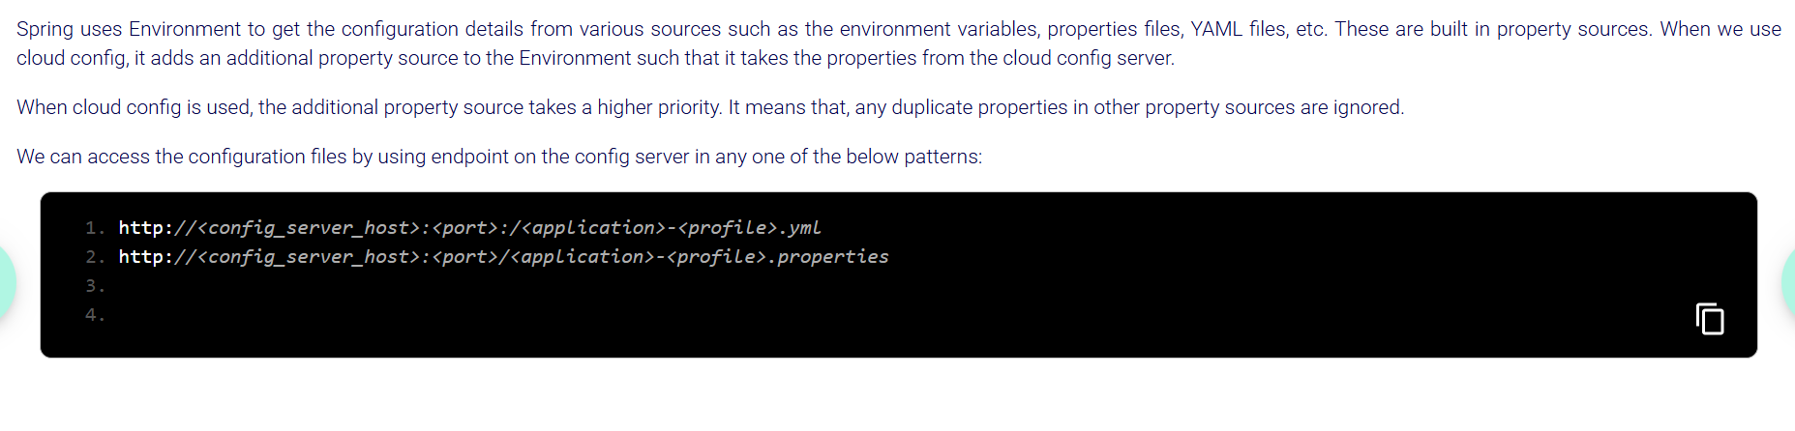

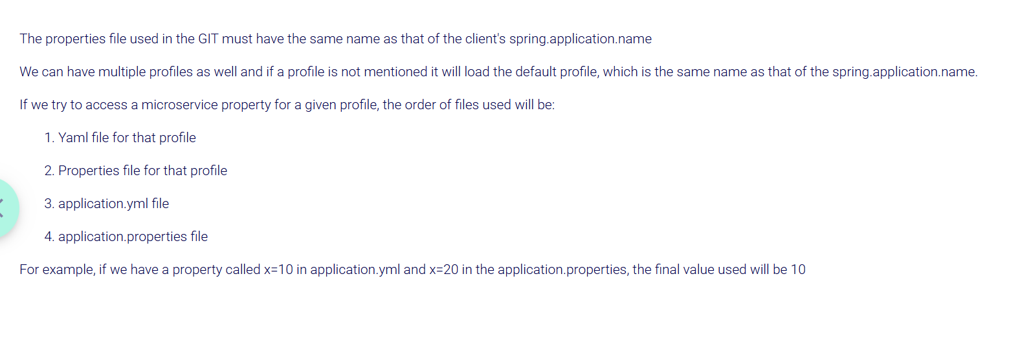



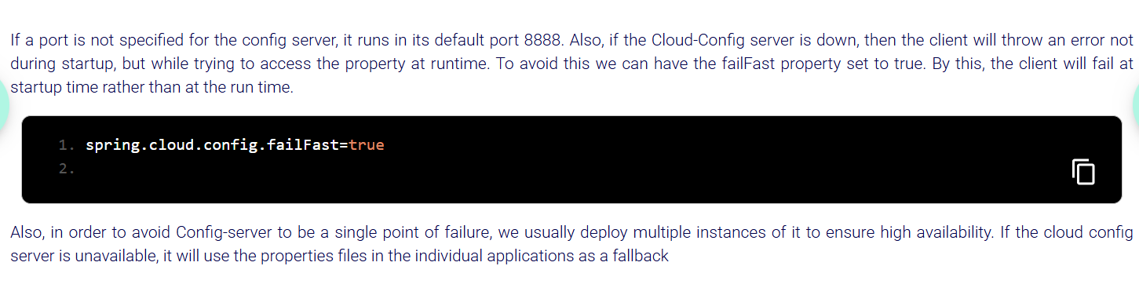

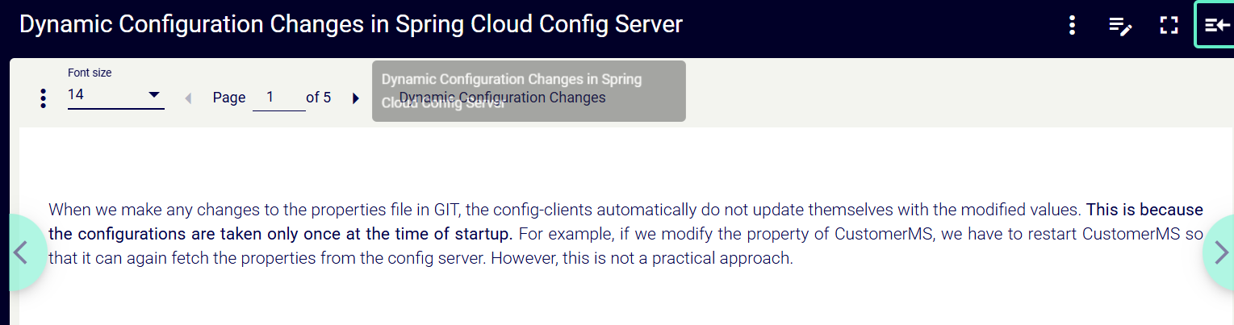

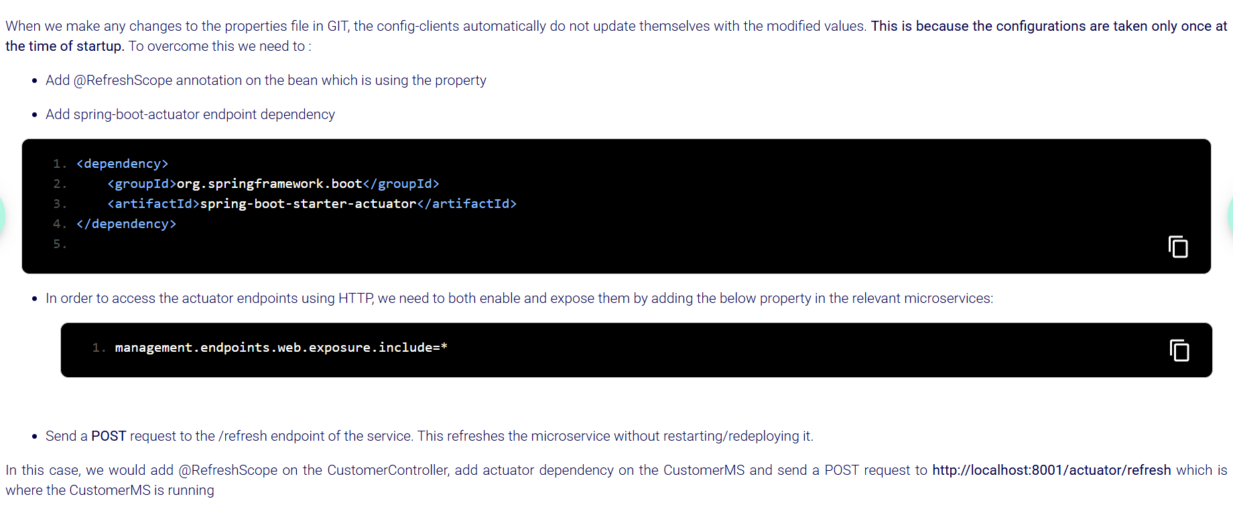

**Enable the @RefreshScope Annotation on Controller:**



**Enable Actuator in Your Microservice**

You need **Spring Boot Actuator** to expose the /actuator/refresh endpoint, which allows you to refresh the application context at runtime. This dependency enables the actuator endpoints

Add the spring-boot-starter-actuator dependency in your pom.xml (if not already included):

<dependency>

<groupId>org.springframework.boot</groupId>

<artifactId>spring-boot-starter-actuator</artifactId>

</dependency>

**Expose the refresh end point:**

To enable the /actuator/refresh endpoint (and other useful endpoints), you need to explicitly configure it in your application.yml or application.properties.

**In application.yml:**

management.endpoints.web.exposure.include=refresh

**Triggering the Refresh event manually**:

**/actuator/refresh** is the endpoint that **re-reads** the config properties from the config server.

POST http://localhost:8080/actuator/refresh

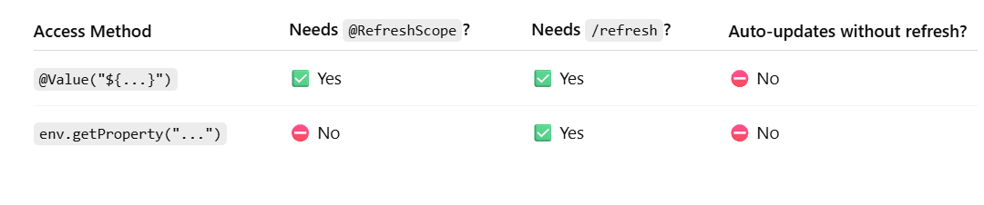

**Using Spring Cloud Bus:**

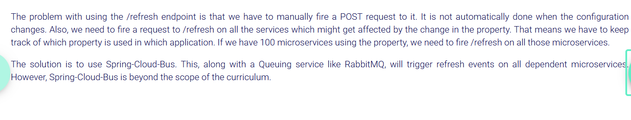

**Quick Summary :::**

* Spring Cloud project allows us to write cloud compatible code
* One of its sub-project is Spring Cloud Config
* Cloud-Config allows keeping all configurations in a central place
* Since this uses the Bootstrap context, we need to use bootstrap.properties file
* A config server contacts the GIT repo.
* The config clients contact the config server at startup to gather the configurations
* Changes made to configurations don’t automatically reflect in the clients
* The configuration files use a specific order of priority.
* yml config has high priority over properties file
* Microservices will access configurations from the config server at the start time only so if config server shutdown also the microservices which are already up and running will not fail.
* If the cloud config server is unavailable, it will use the properties files in the individual applications as a fallback
* Configurations are taken only once at the time of startup. Need to add actuator dependency with @RefreshScope annotation on the bean which is using the property also POST request to the /refresh endpoint
* If we are accessing default profile for CustMS from config server it will be served by default in JSON format

If Below are some of the config files in the cloud. What will be the final value of the property hello in a microservice with spring.application.name “CustMS”? Ans : Spring (because *value from default profile(CustMS) will be used)*

**application.yml:**

hello: world

**application.properties:**

hello=Infy

name=test

**CustMS.yml:**

hello: Spring

***Load Balancing:***



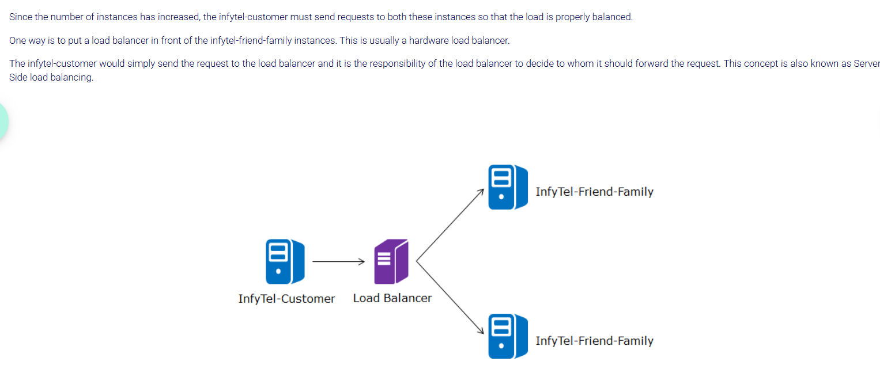

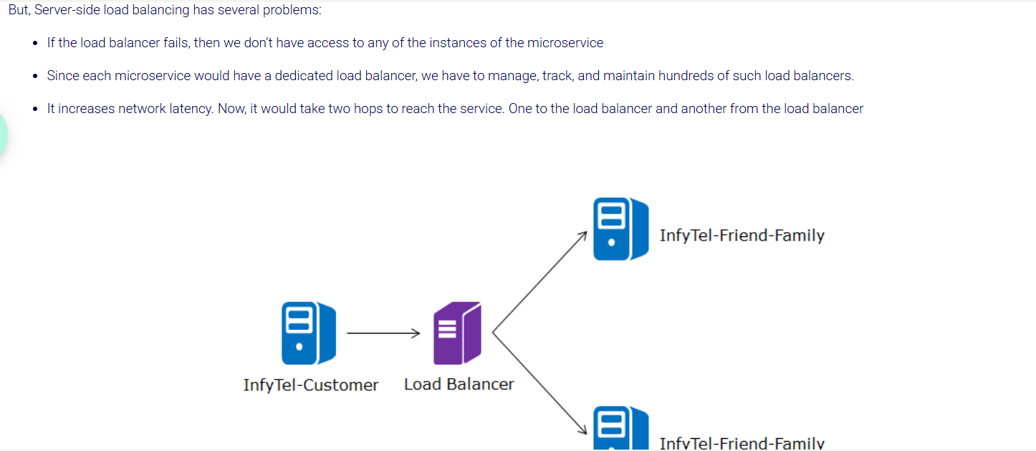

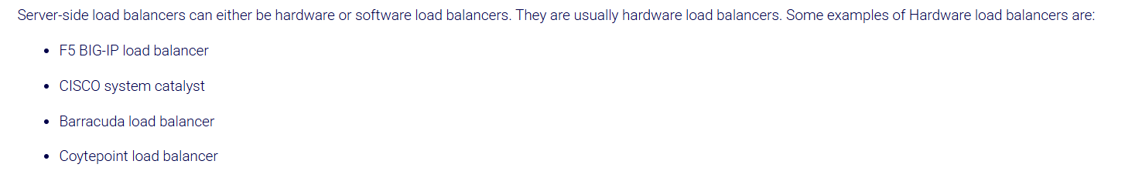

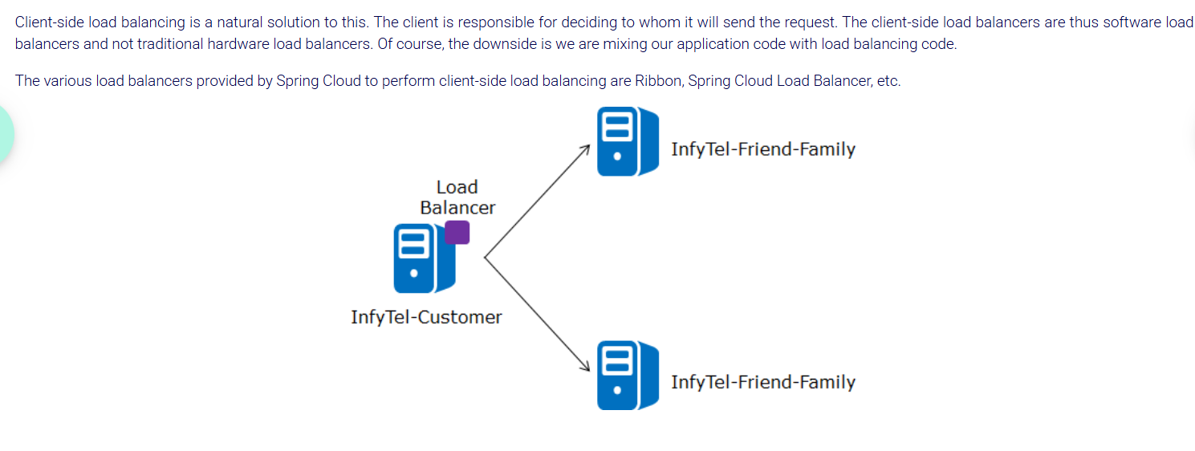

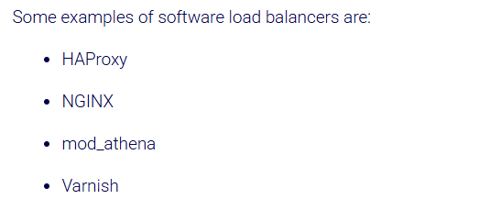

**Steps:**

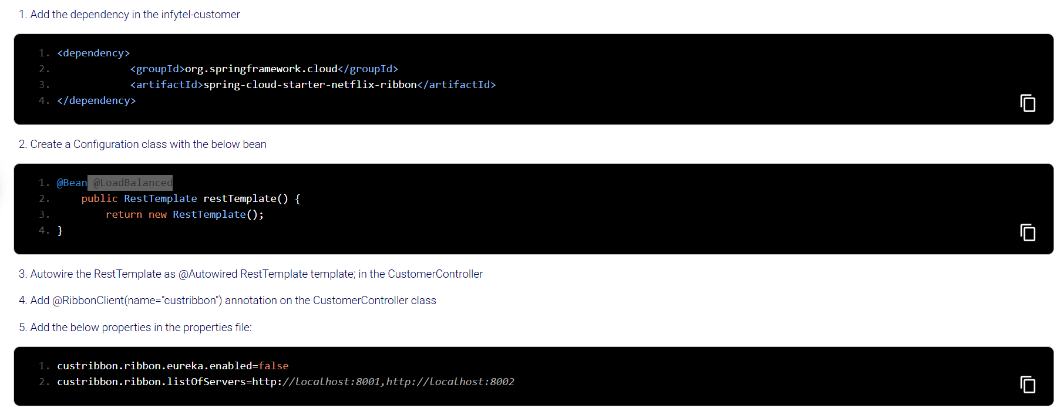

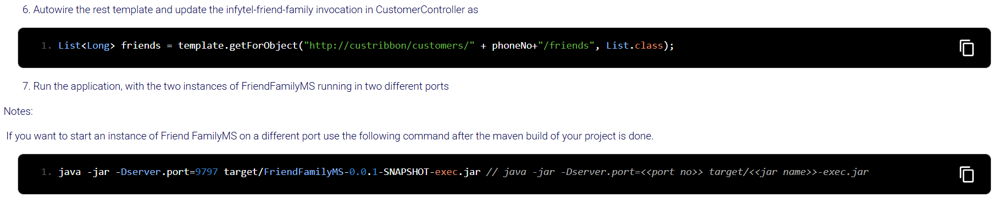

custribbon looks for the servers it has to loadbalance across and works like a roundrobbin means one request goes to one instance and second request goes to second instance and again next request goes to first instance like this.

If one instance is down then when request goes to that instance which is down gives error.

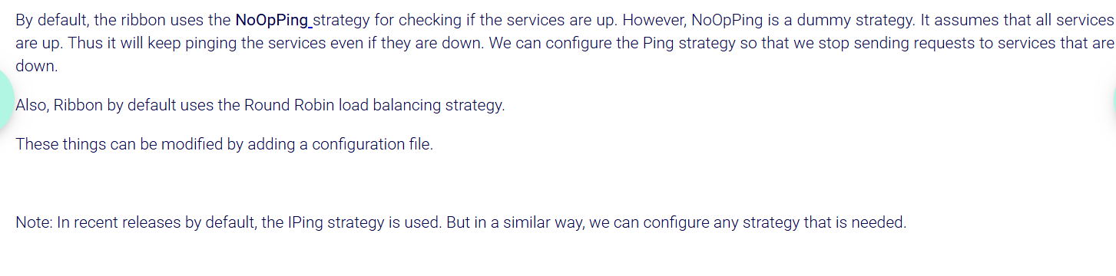

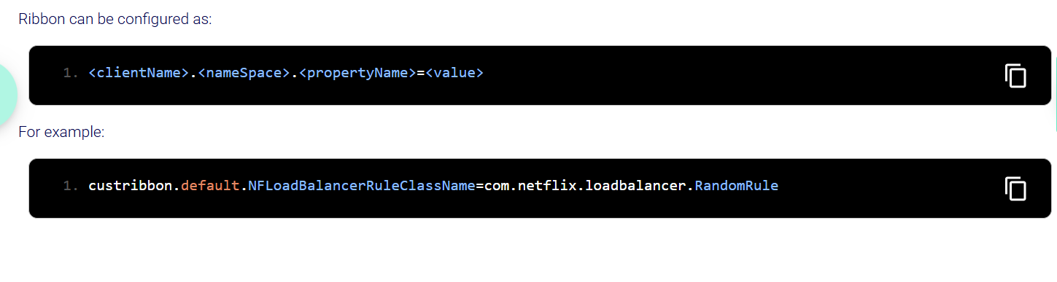

• **NFLoadBalancerRuleClassName**: This is the property that defines which load-balancing rule to use. It’s part of Ribbon’s configuration for how the client should choose an instance to route a request.

• **com.netflix.loadbalancer.RandomRule**: This is the value assigned to the property, which specifies that the **RandomRule** should be used for load balancing. The **RandomRule** means that Ribbon will randomly pick a server from the available servers in the list.

In **iping** strategy if the service is down it will wait for specific duration and then it will stop pinging.

***Service Discovery:***

Eureka acts as a service registry where all microservices register themselves in it. It enables service discovery, allowing microservices to find and communicate with each other without hardcoding service locations.

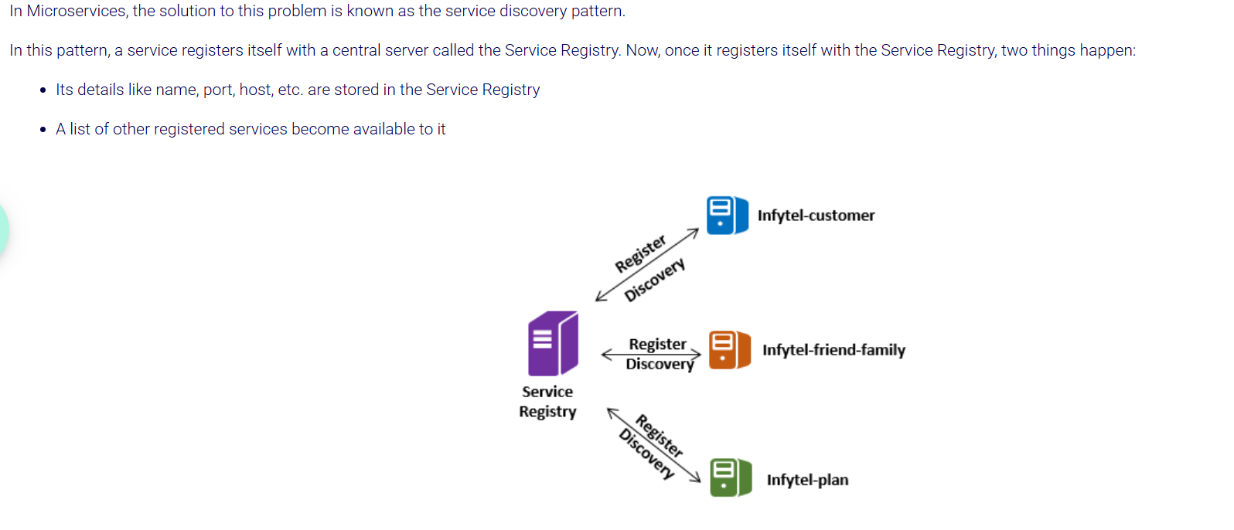

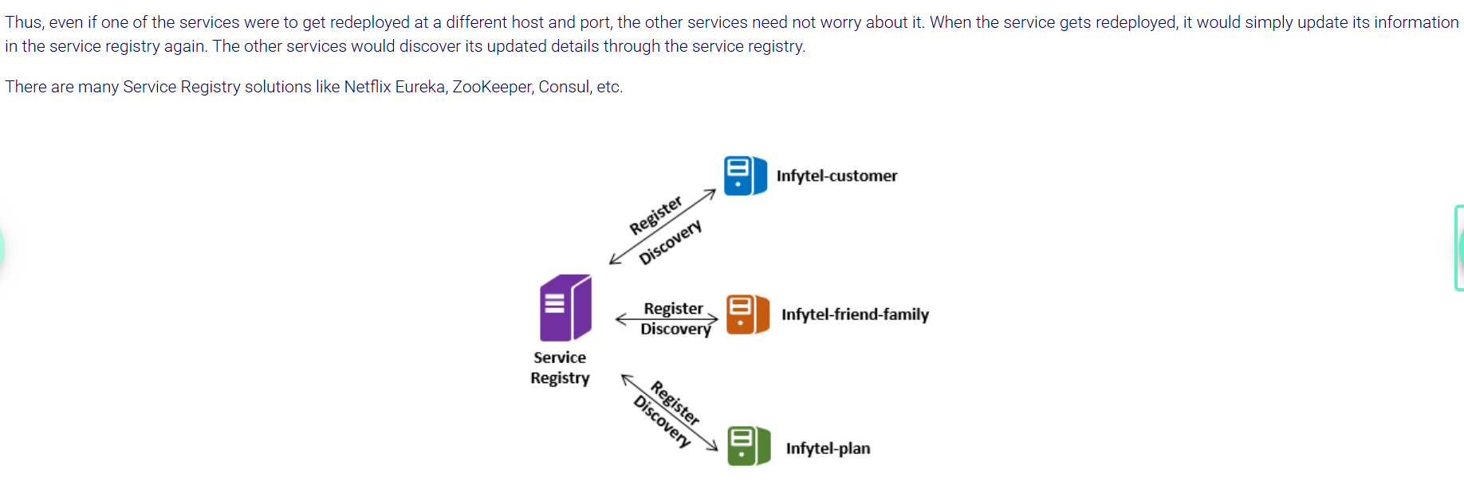

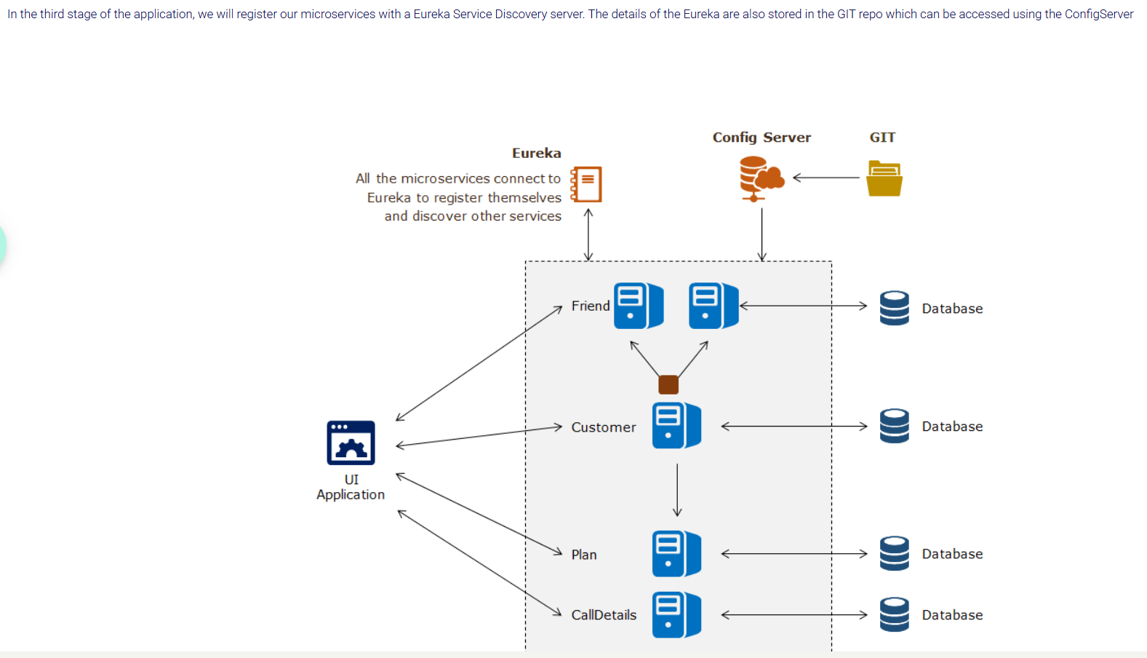

STEPS::

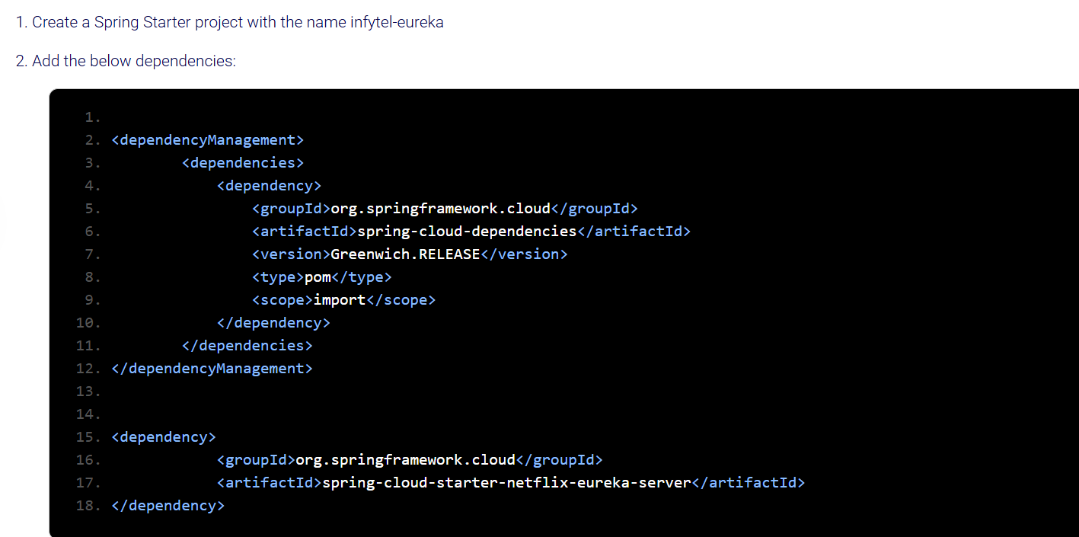

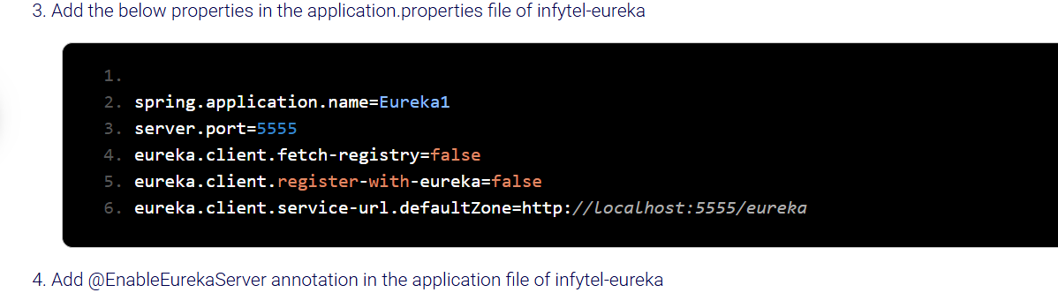

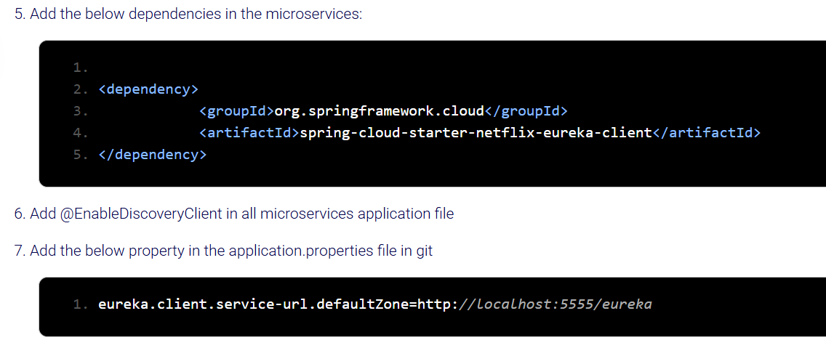

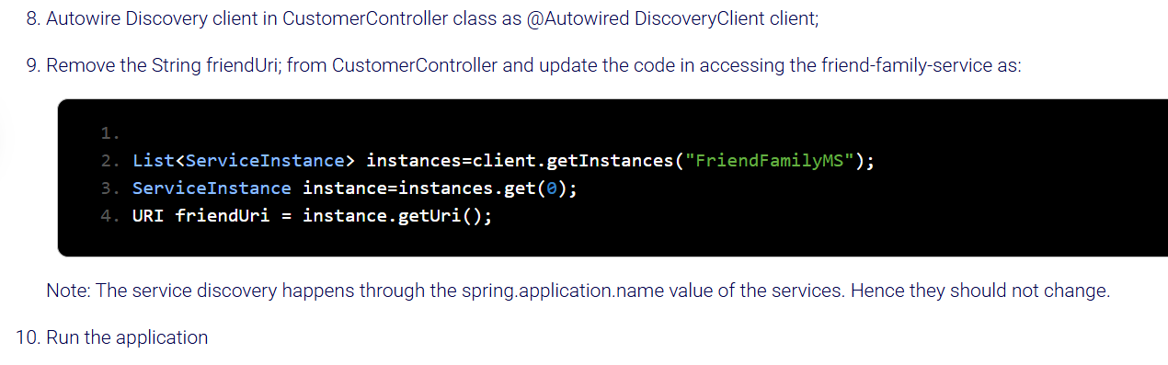

Below is the Eureka dashboard where we can see the running services registered with eureka. Eureka removes that service or instance from dashboard if service is down.

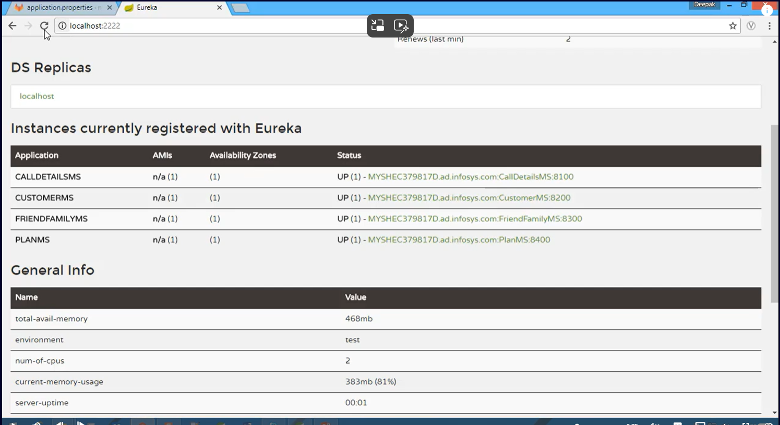

To see the instances and more ::

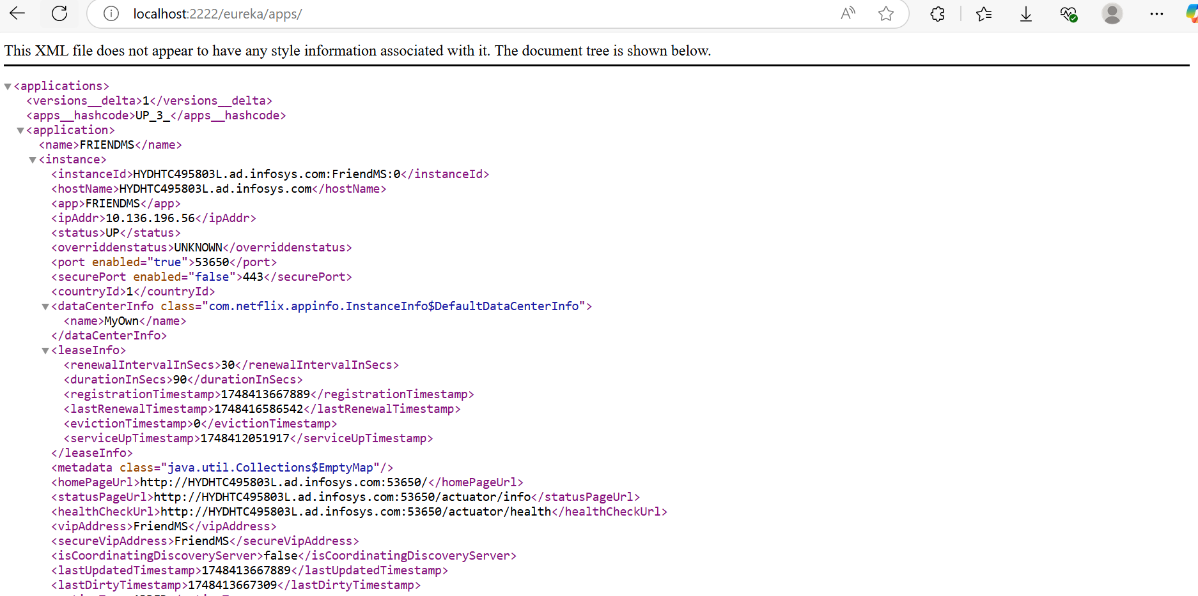

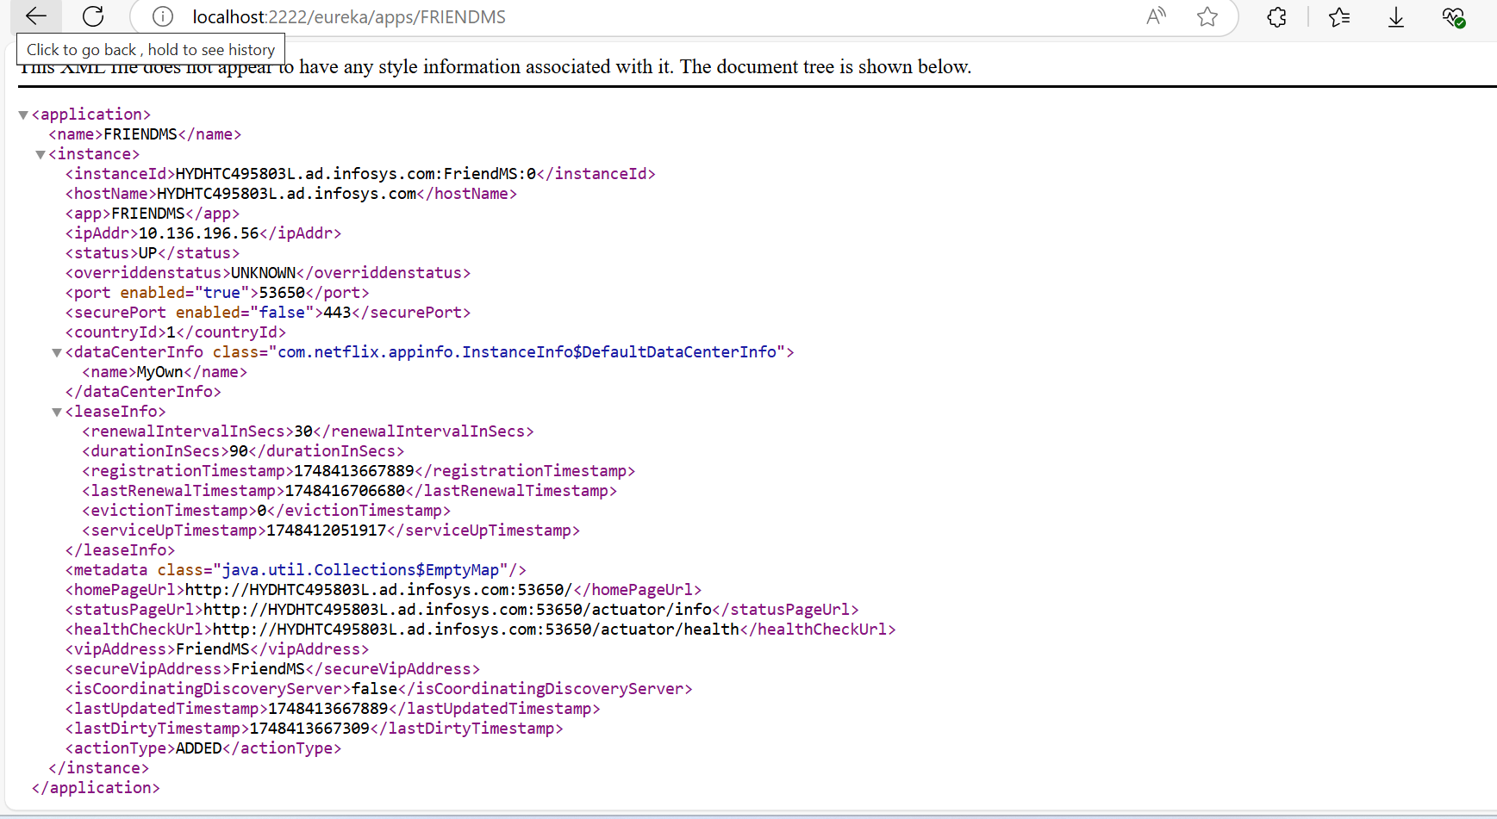

List<ServiceInstance> list = client.getInstances("FRIENDMS");

is used in a Spring Cloud application that uses Service Discovery (typically with Eureka) to programmatically get all instances of a microservice (FRIENDMS)

List<ServiceInstance> list =client.getInstances("FRIENDMS");

ServiceInstance serviceInstance2 = list2.get(0);

URI friendUri = serviceInstance2.getUri();

This is to get the uri of specific instance.



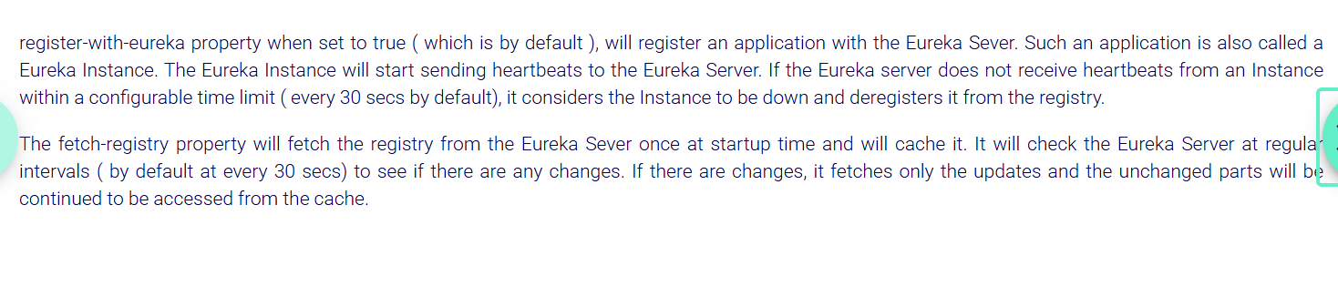

**Explanation for above..**

**•** Eureka Instance:Every application registered with Eureka Server is called a Eureka Instance. It’s basically a service that Eureka knows about.

**•** Eureka Client:Since each Eureka Instance can also fetch details about other Eureka Instances, it acts as a client to discover services.

So, an app registered with Eureka is both an Instance (itself) and a Client (fetches info about others).

register-with-eureka property - When set to **true** (default), your application **registers itself with the Eureka Server**. This means it will be listed as available in the Eureka registry.It will also **send heartbeats (regular signals) to the Eureka Server** to say, "I'm alive!"

* When your **Eureka client** (a service that wants to discover other services) starts, it **fetches the entire registry** (a list of all available services) from the **Eureka Server** **once at startup**.
* After that initial fetch, the client **stores this registry data in its local cache**.
* Then, the client **periodically checks the Eureka Server** every **30 seconds (default)** to see if there are **any changes** in the registry (like new services registered, or some services went offline).
* If there **are changes**, instead of downloading the whole registry again, the client **only fetches the updated parts** (the differences).
* For all the services that **haven't changed**, the client continues to use the data from its **local cache**.
* This approach **reduces network traffic** and **improves efficiency** by avoiding downloading the full registry every time.



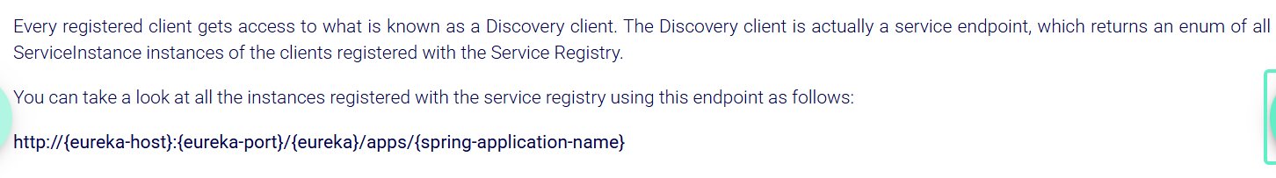



***Ribbon with Eureka:***

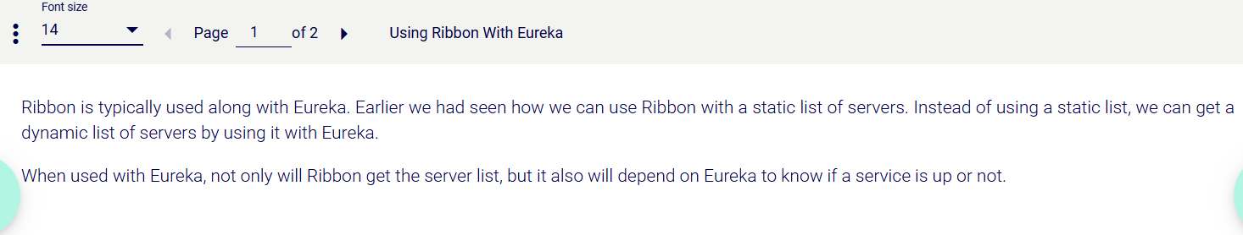

***Steps:***

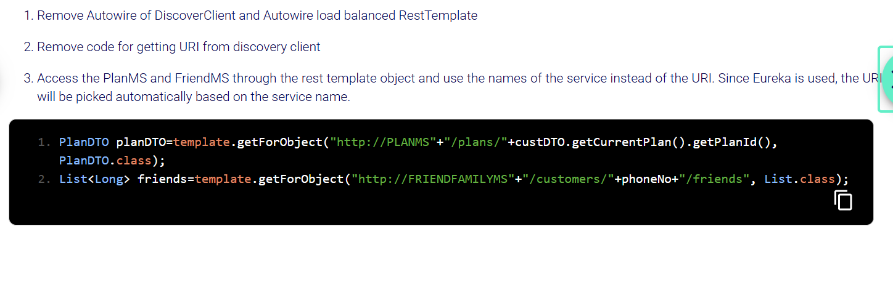

In the above, template is the autowired load balanced rest template which itself is a ribbon concept and when application name is used to get instances we get all instances through eureka and here ribbon(loadbalanced template) load balances the instances of this application(FriendFamilyMS)

Add this below property in FriendFamilyMS.properties in git so that instance ids for both instances would be different so that eureka registers them both.

If this property is not mentioned then each instance of microservice would get same instance id and override with each other and only last instance would get registered in eureka.

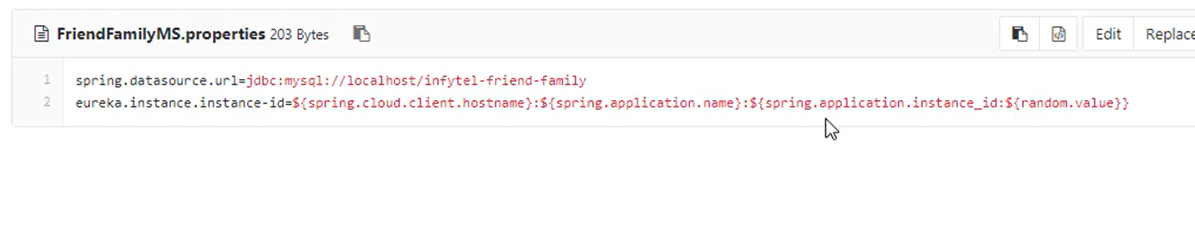

***Example:***

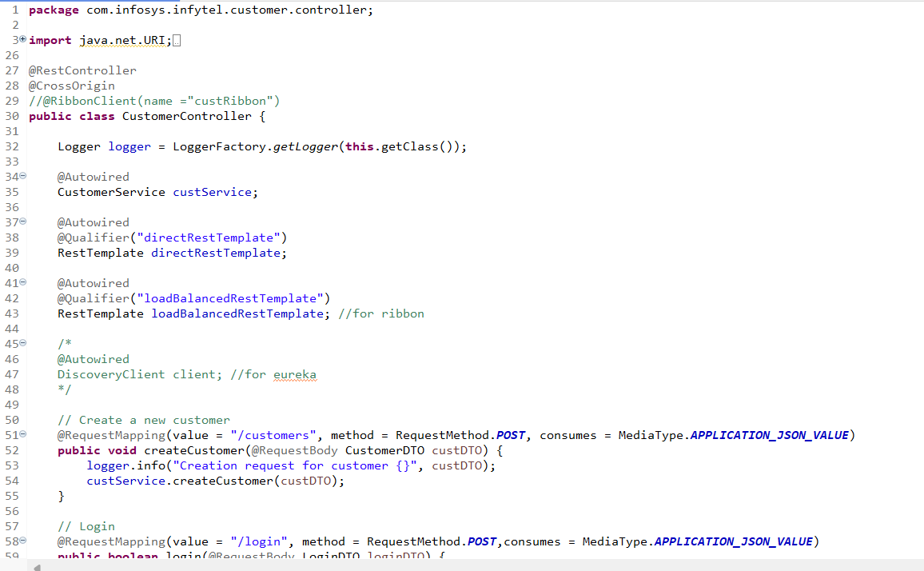

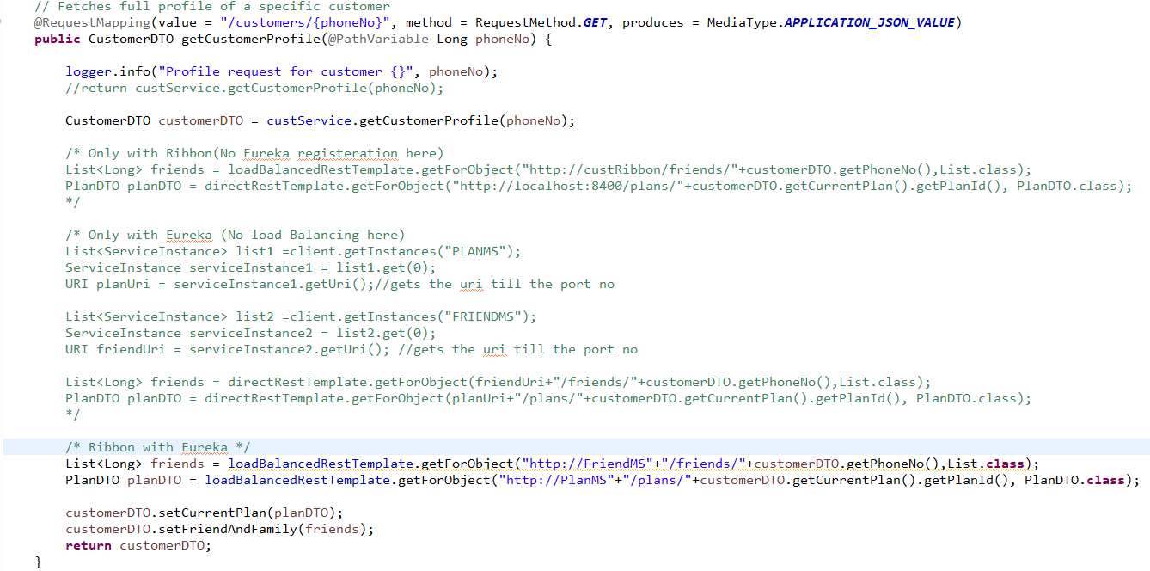

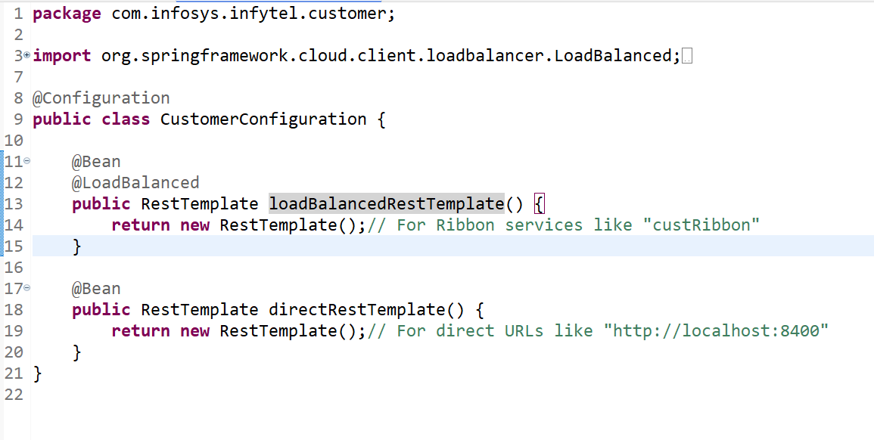

***Eureka Cluster::***

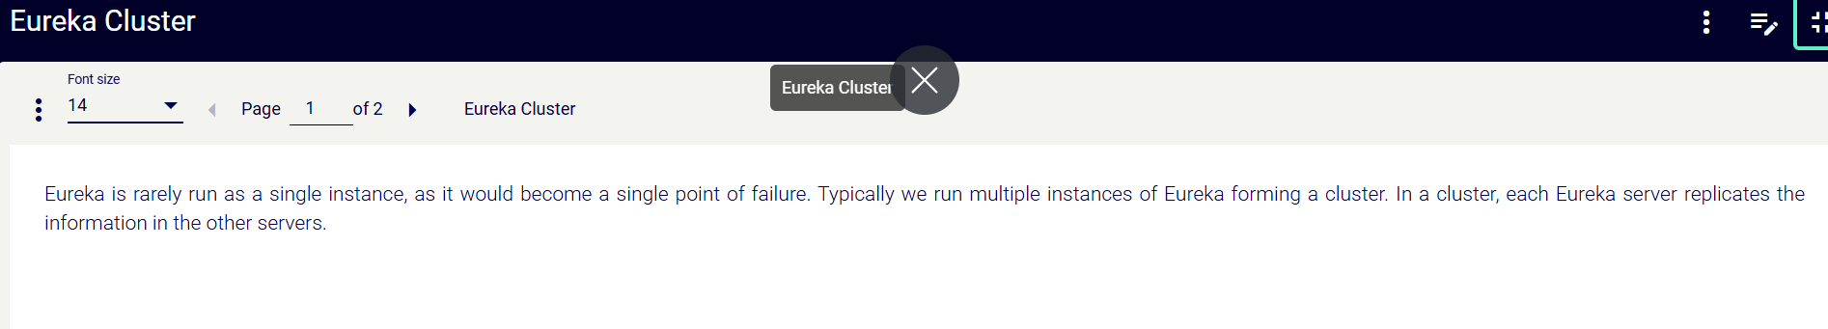

***Circuit Breaker & Resilience (using Resilience4j or Hystrix)***

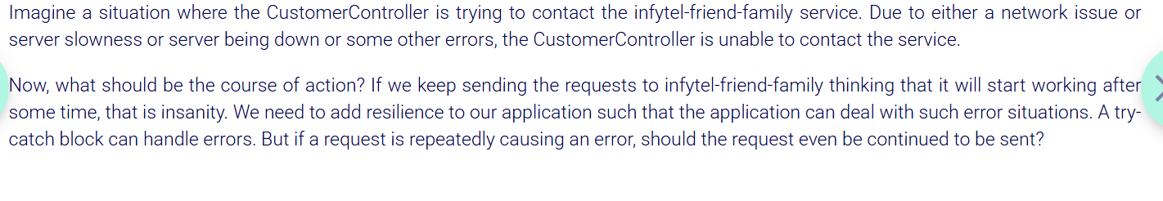

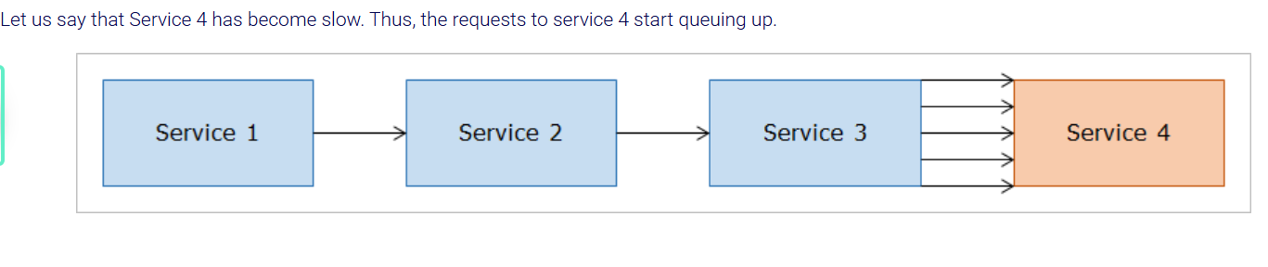

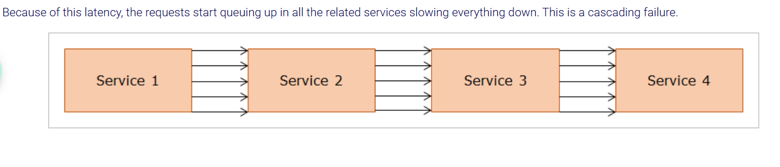

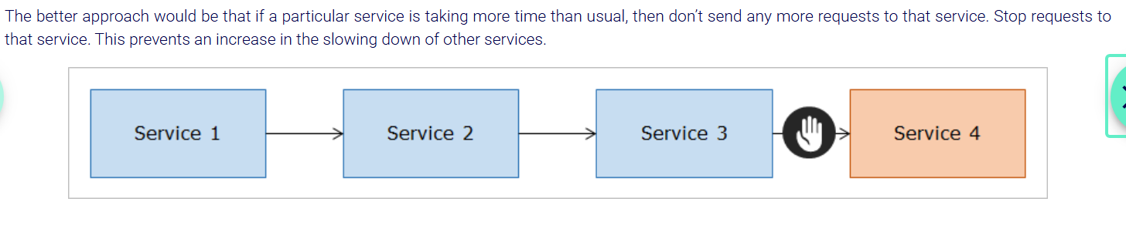

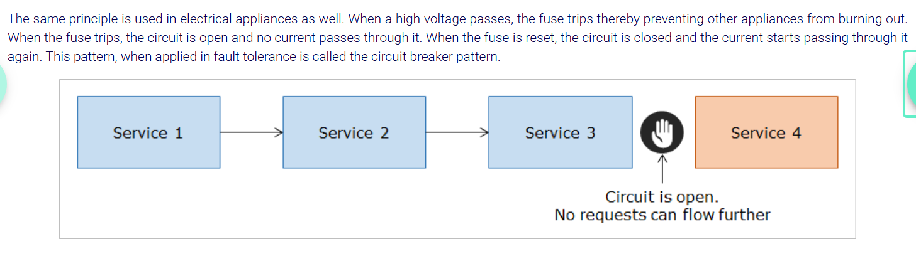

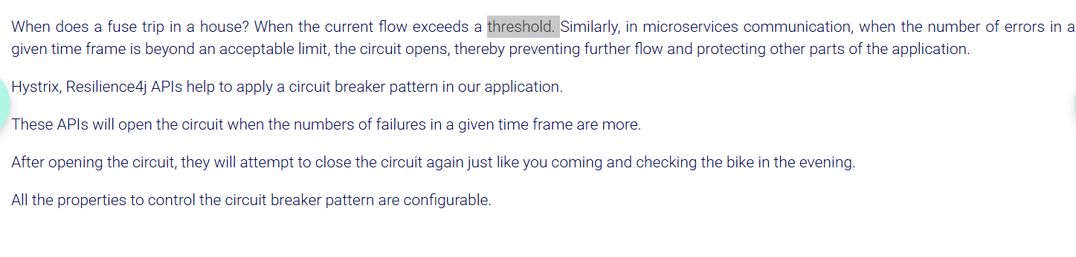

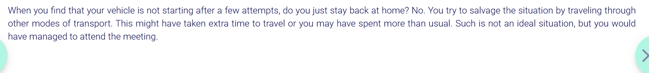

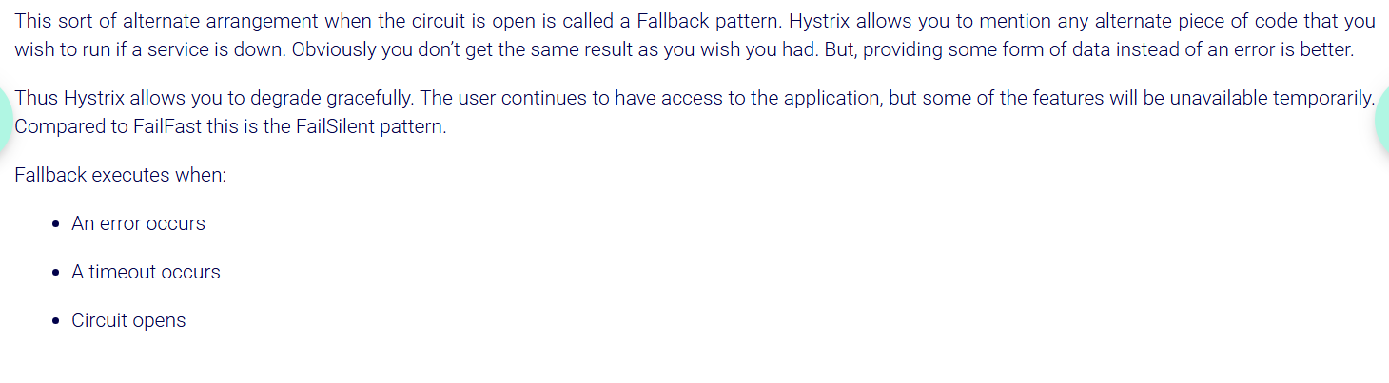

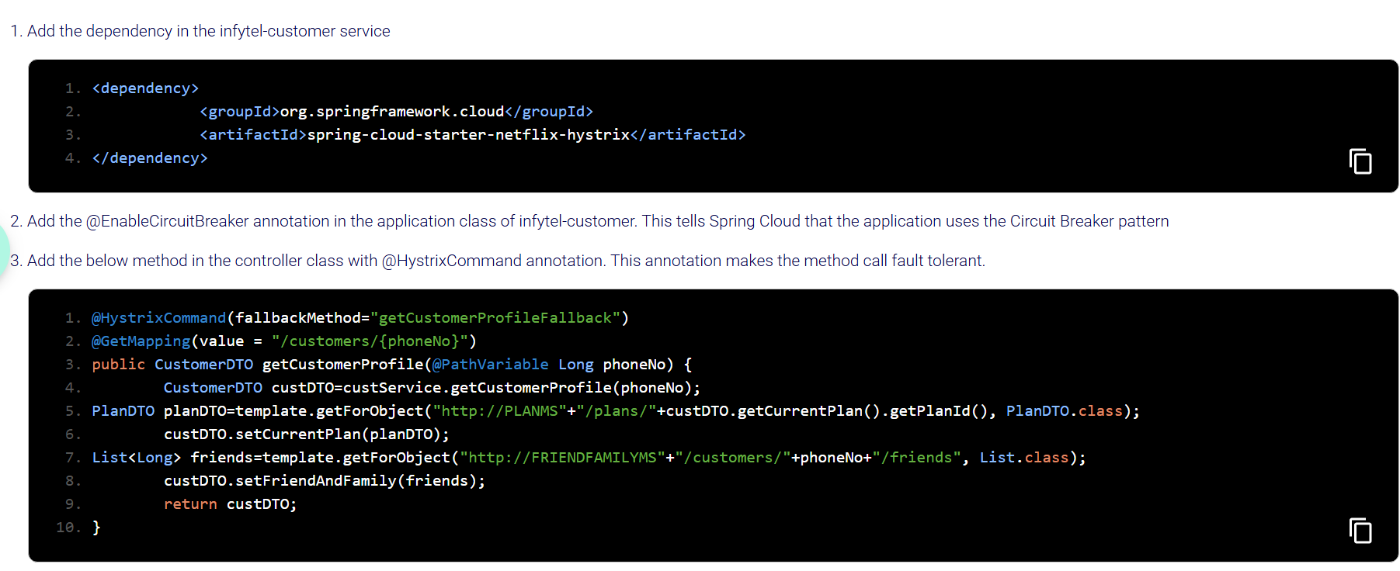

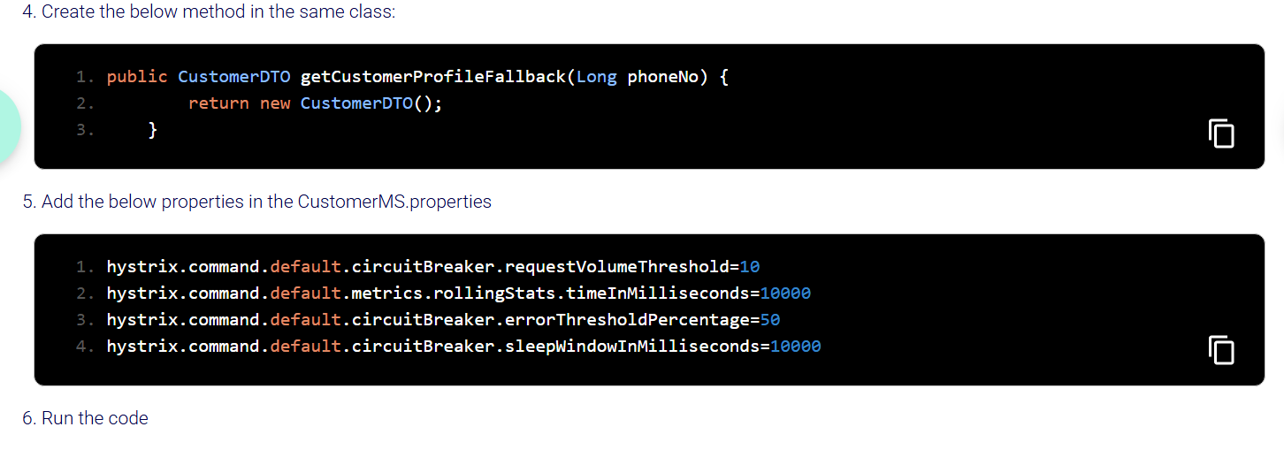

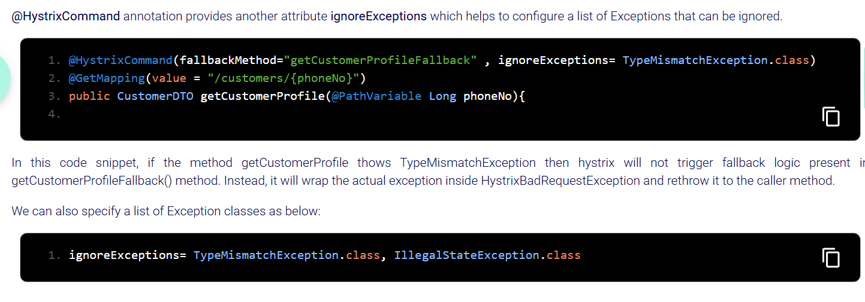

Here throws exception when it meets phoneno condition in FriendFamilyMS where Customer is hitting this MS for info. When Rest call is made from customer if it meets this condition throws exception and goes to fallback method. This happens for min requests made with in time limit and only if 50% of requests fail(throws error). Once min requests are done and any request later on after the time limit request will go only to fallback method without actually going to rest controller method. this happens due to circuit opens after time limit. Circuit remains open for 60 seconds after this time limit like 20sec lets say. and in this mean time (in 60sec)all requests even valid ones goes to only fall back methods.

So After 60 seconds, circuit gets closed and we can give valid request first to remain closed. But instead of giving valid request after 60 sec of circuit being open, if we give invalid request again circuit becomes open for 60 secs again after the first request.

Instead of giving invalid request after circuit is open for 60sec, then try to make first request pass or valid.



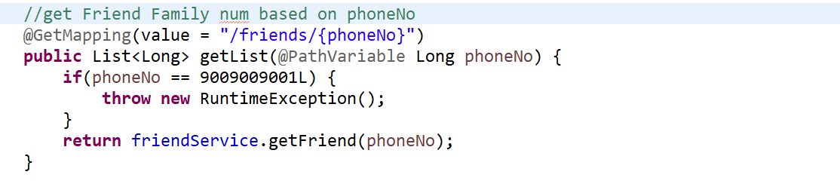

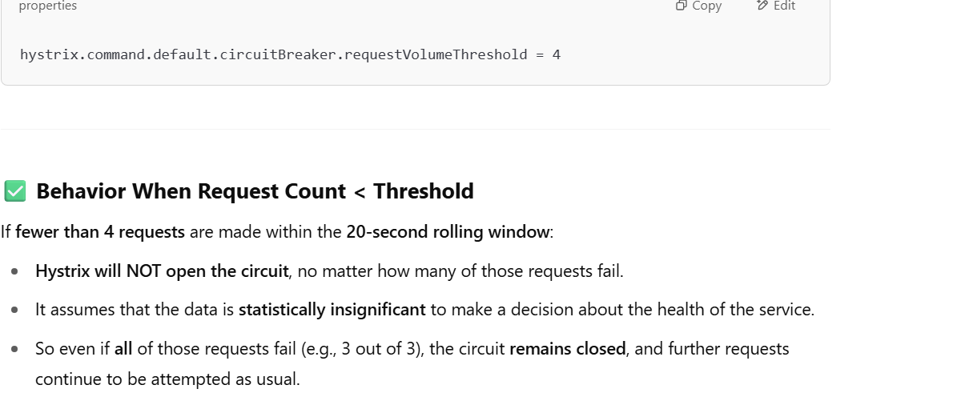

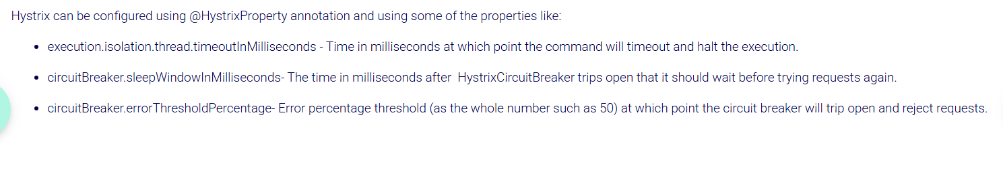

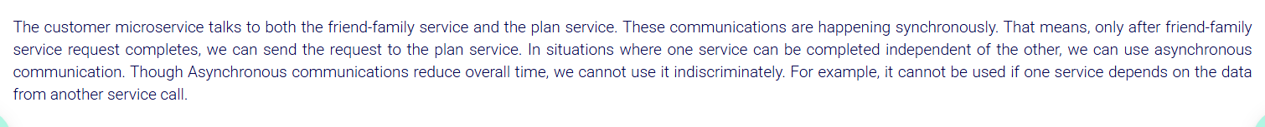

***API Gateway:***

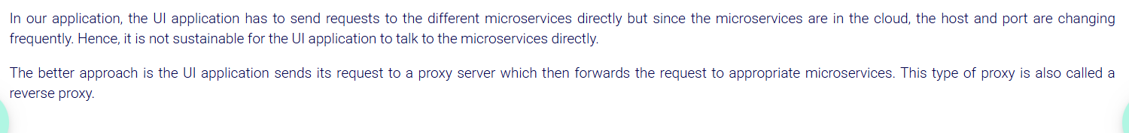

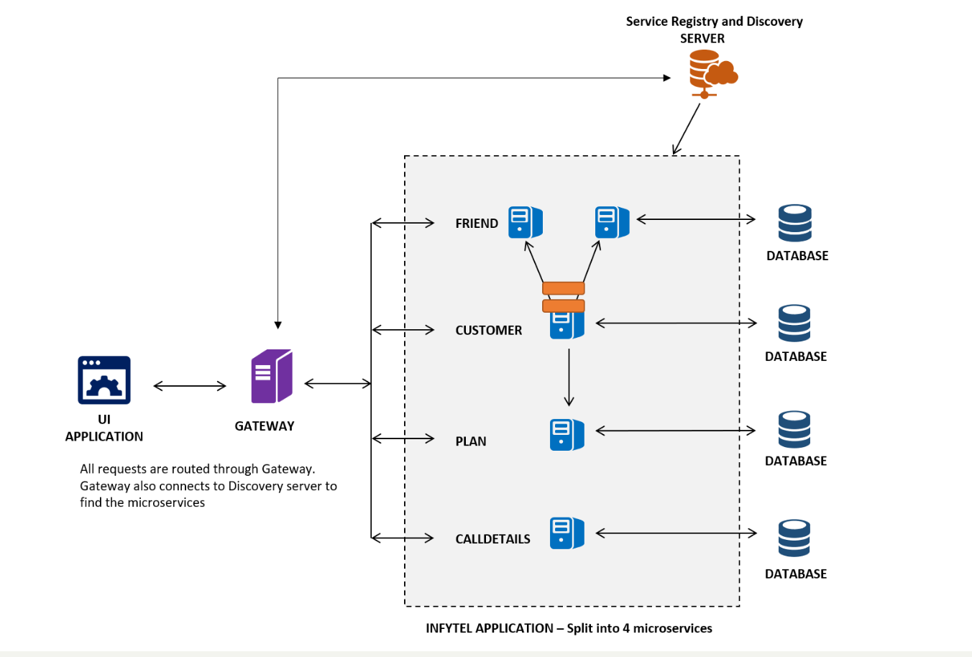

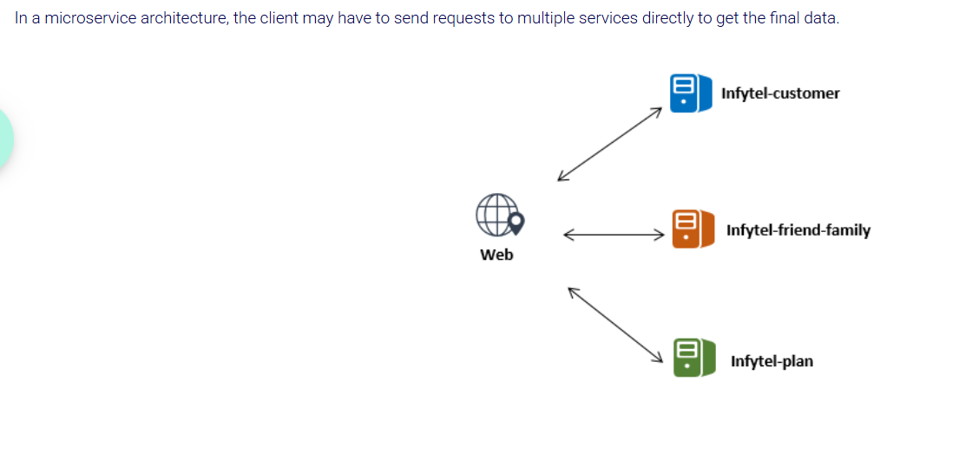

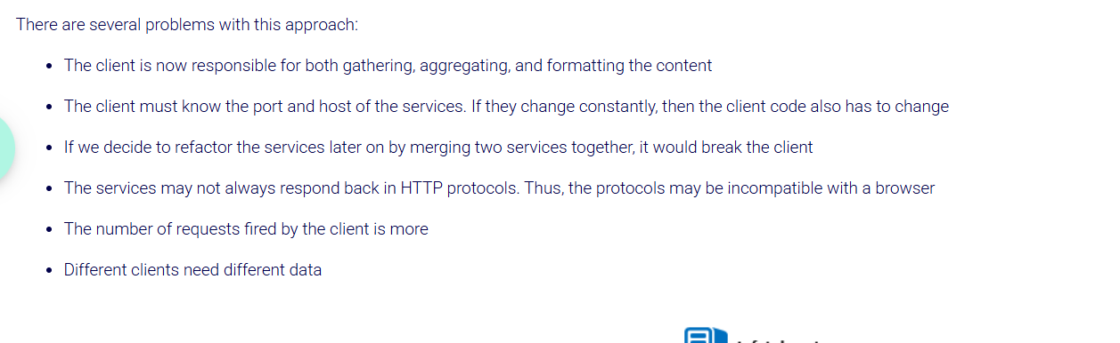

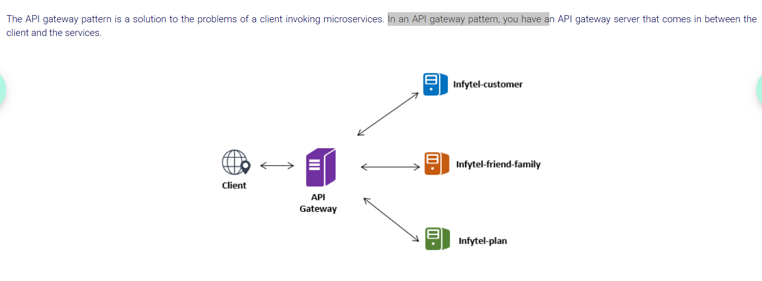

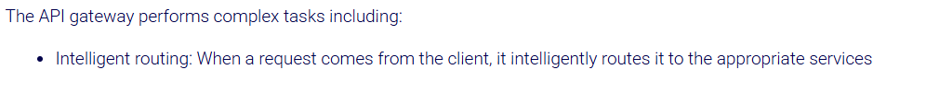

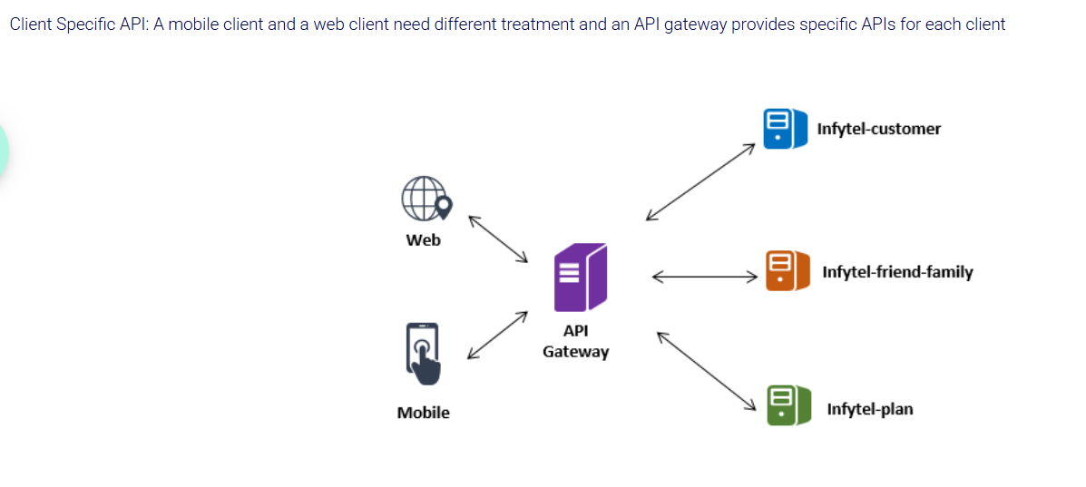

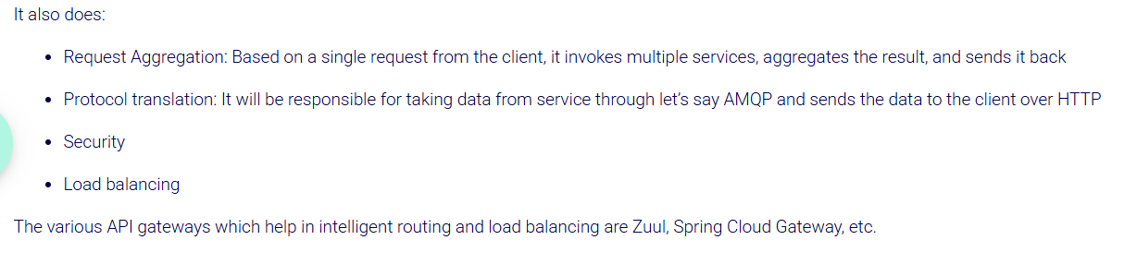

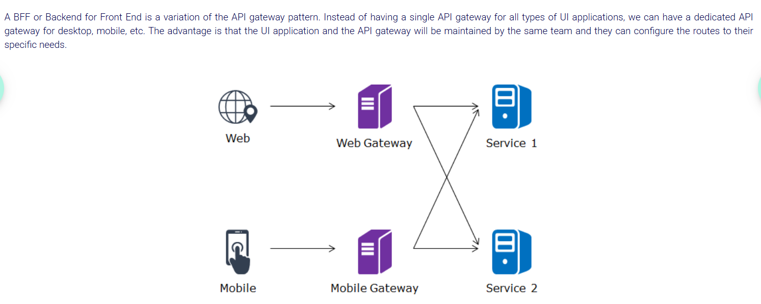

An **API Gateway** acts as a **single entry point** for all client requests to the backend services in a microservices architecture. Instead of clients making multiple requests directly to individual microservices, they can interact with the API Gateway, which will then route those requests to the appropriate microservices.

In the context of Spring, this concept is implemented using **Spring Cloud Gateway** or **Zuul** (the older solution, though Spring Cloud Gateway is now the preferred approach).

**Why Use an API Gateway in Microservices?**

Here are a few reasons why an API Gateway is important in a microservices environment:

1. **Single Entry Point**:
   * The API Gateway provides a unified access point for clients (mobile apps, browsers, etc.) to interact with the various microservices. This simplifies communication between clients and services.
2. **Routing Requests**:
   * The API Gateway can route incoming requests to the appropriate microservice. For example, it can forward requests to the user-service for user-related operations, or to order-service for order-related operations.It checks incoming requests (based on URL paths, headers, or other criteria) and forwards the request to the correct service.
3. **Load Balancing**:
   * The API Gateway can provide load balancing, distributing requests evenly among multiple instances of a microservice to improve scalability and reliability.
   * • The API Gateway uses **service discovery** (e.g., with Eureka) to dynamically find all available instances of a microservice.
4. **Security**:
   * The API Gateway can manage security, such as authentication and authorization (e.g., OAuth2, JWT tokens), before forwarding requests to the backend services.
5. **Cross-Cutting Concerns**:
   * It can handle things like **rate limiting**, **logging**, **caching**, **API versioning**, and **response transformation** in one centralized place, rather than scattering those concerns across each individual microservice.
6. **Aggregation**:
   * It can aggregate responses from multiple microservices into a single response. This is useful when a client needs data from multiple microservices.

So , Api gateway registers itself with eureka to discover and **route requests** to services.

• ✅ Create a new project for api gateway✔️

• ✅ Add Gateway and Eureka client dependencies in pom.xml✔️

• ✅ (Optional) Add @EnableEurekaClient on top of main class✔️

• ✅ Add routing and Eureka config in application.yml ✔️

• ✅ Make sure your services (user-service, etc.) are registered with Eureka ✔️

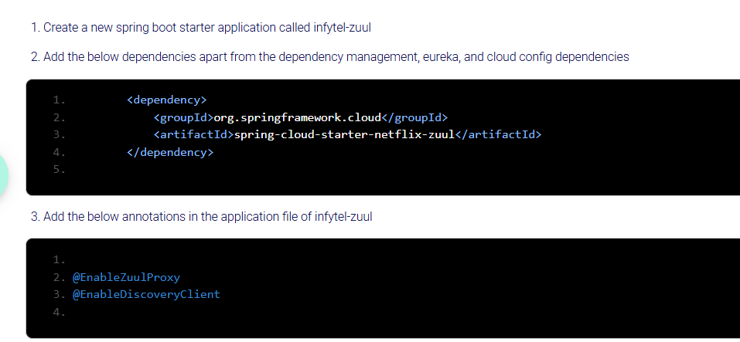

Create bootstrap.properties and add cloud config details to fetch the eureka details for registration.

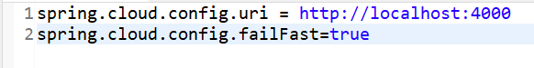

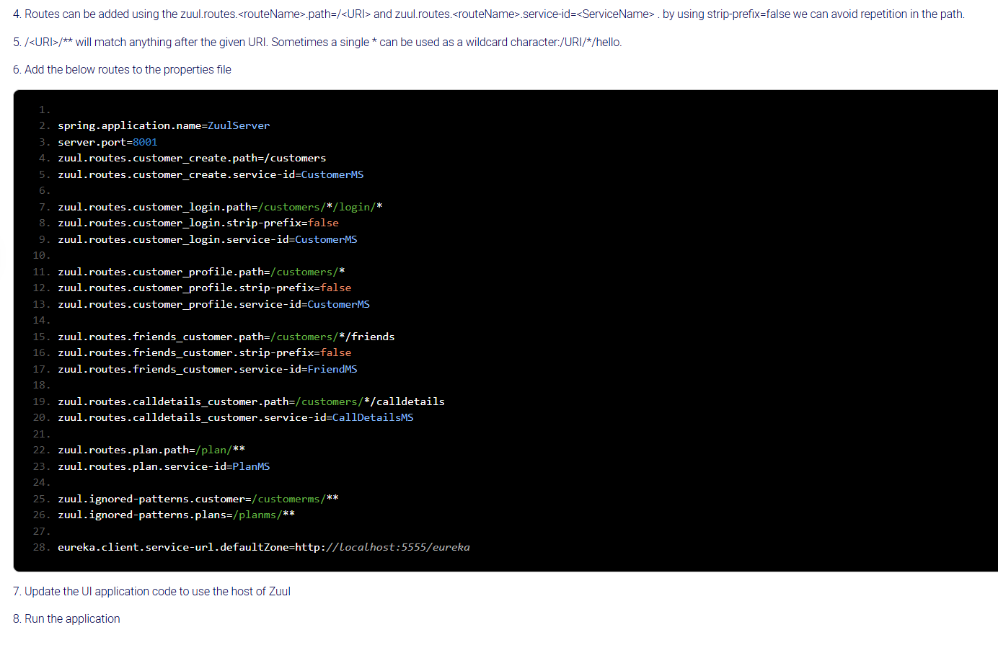



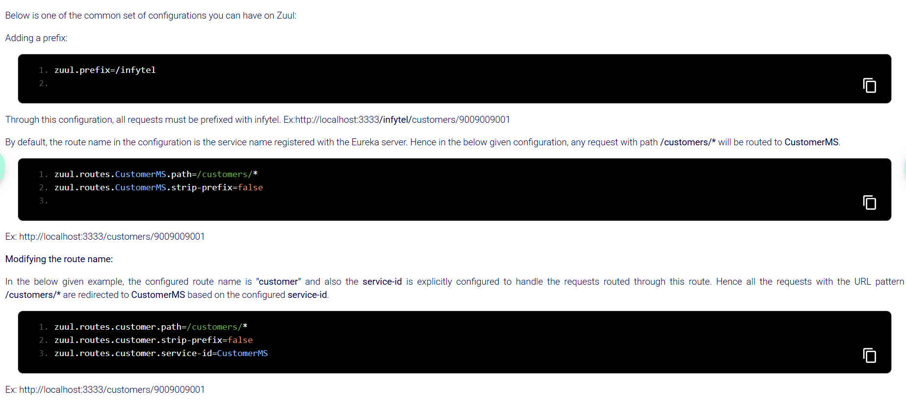

Zuul automatically load balances the request coming to it.

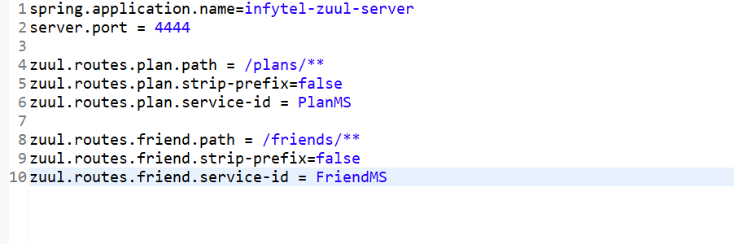

When there are more than one instance of FriendandFamily MS then it loadbalances the requests to the instances like round robin way.

**Zuul and Hystrix:**

You want a Java class that tells Zuul how to respond when one of your backend services fails or times out.

Zuul is a gateway that routes requests to other services. Sometimes those services are down or slow, so you want a fallback response — a friendly message instead of a scary error.

**• It applies to all routes (all backend services Zuul talks to).**

**• If the service times out, it returns HTTP 504 Gateway Timeout with a message.**

**• For other errors, it returns HTTP 500 Internal Server Error with the same message.**

**• The message it sends back is "Sorry. Something went wrong".**

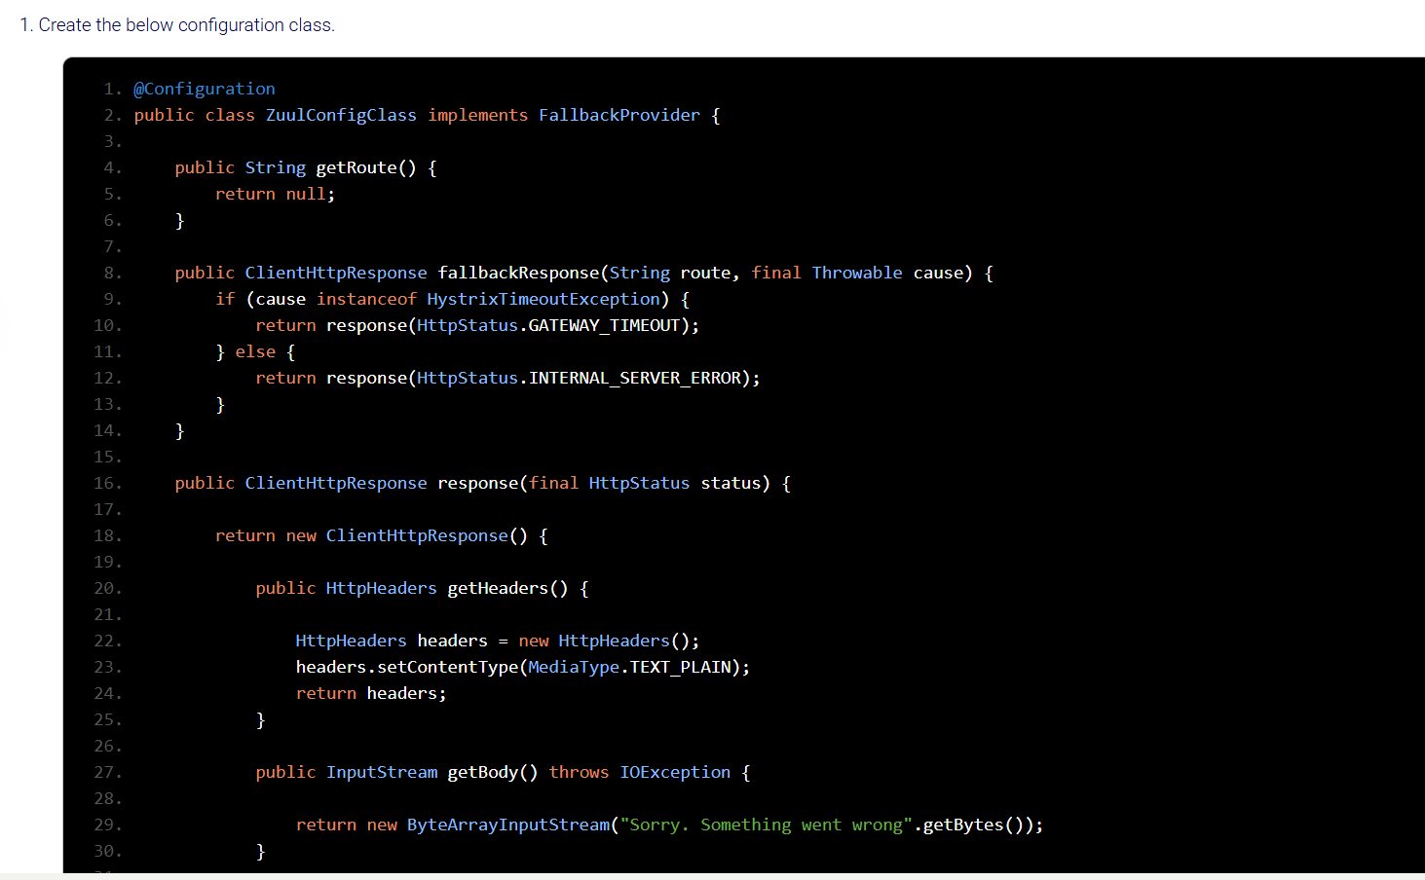

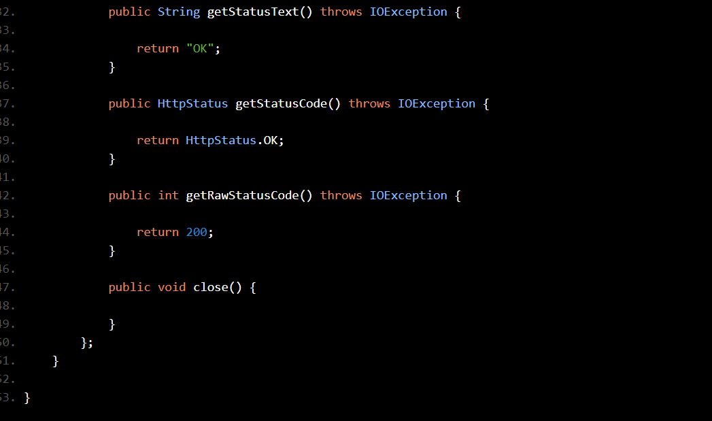



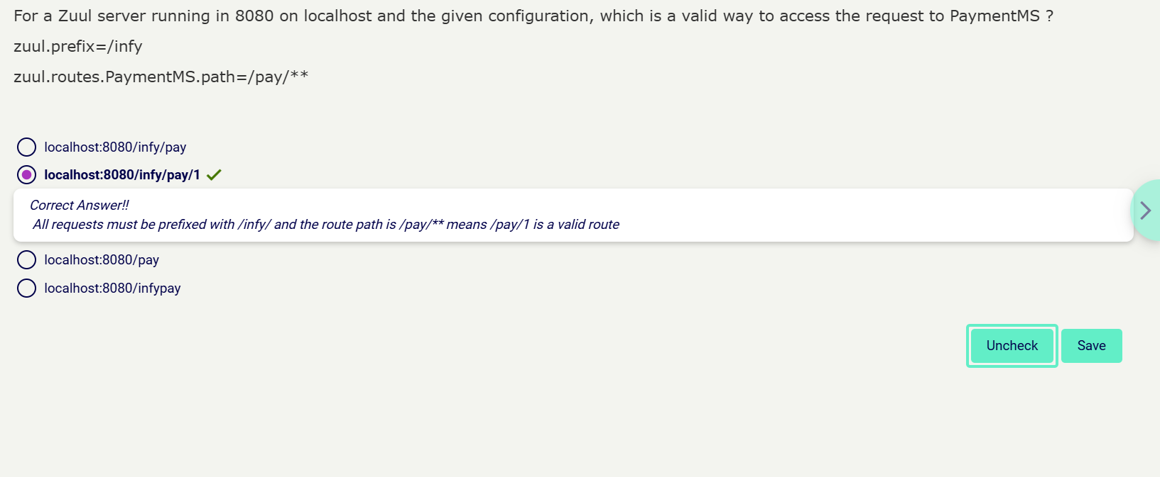

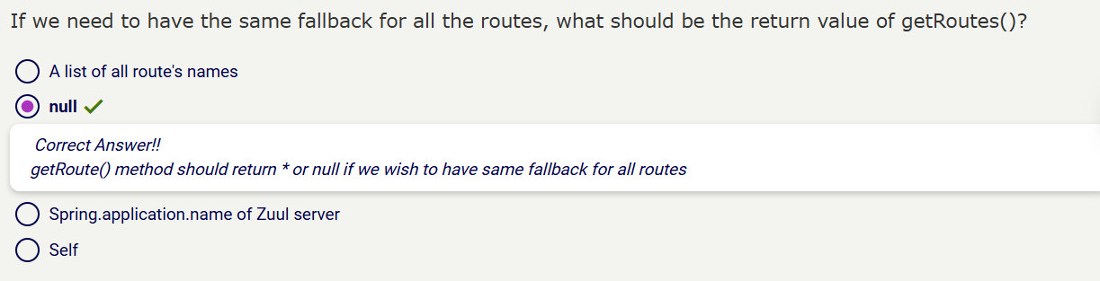

**Feign Client (Declarative REST Client)**

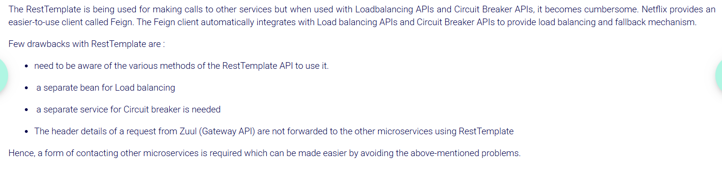

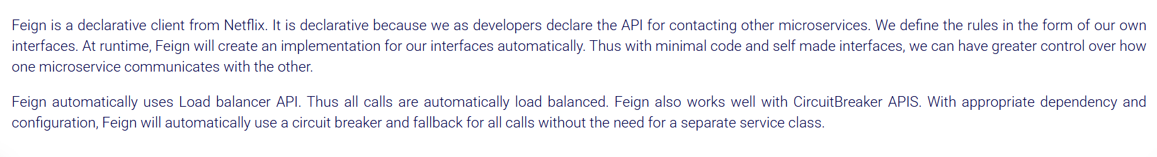

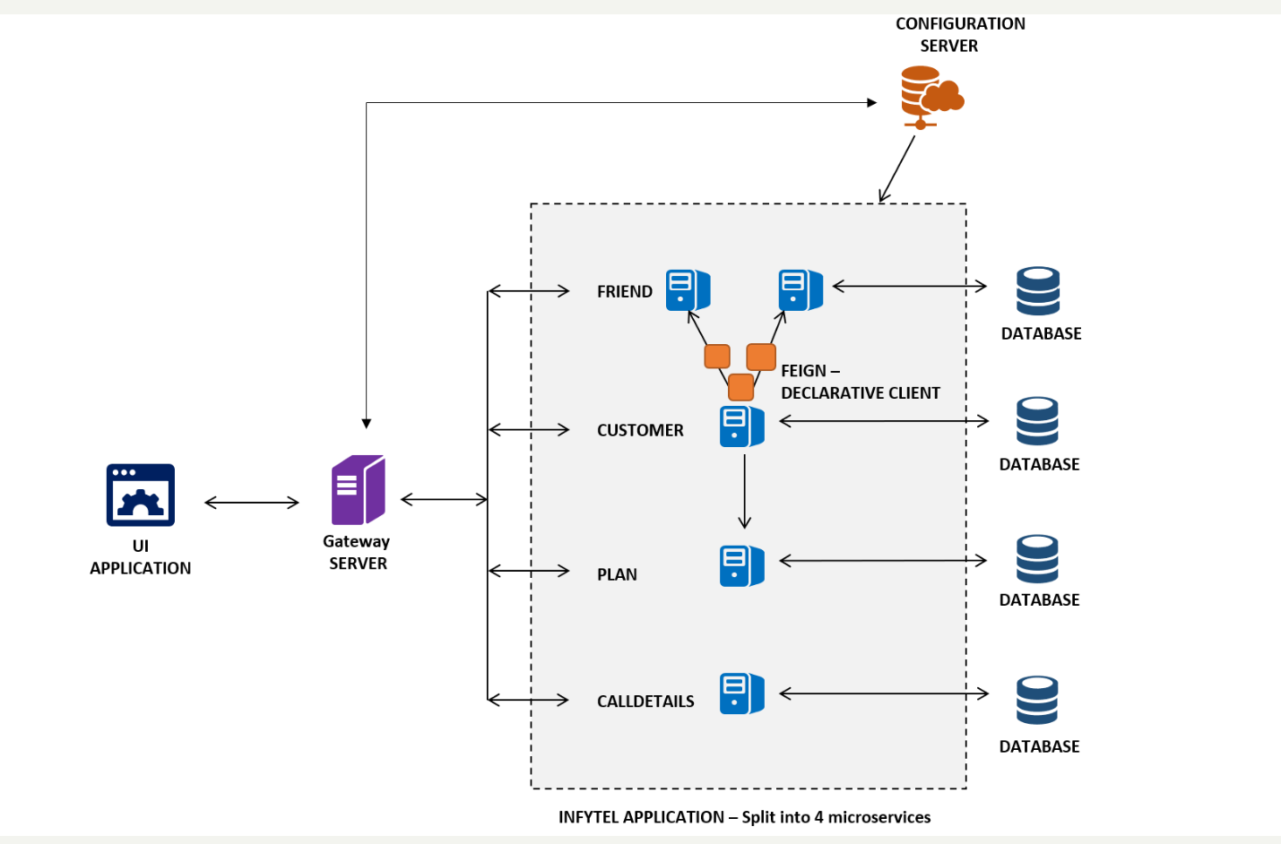

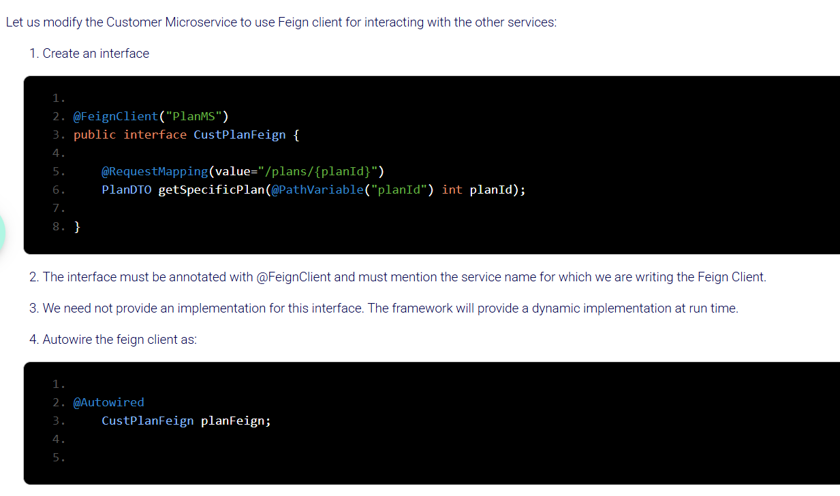

* Add @EnableFeignClients annotation on Customer Main class

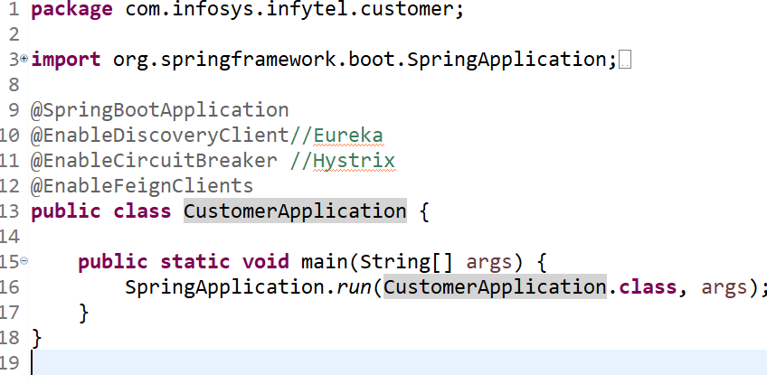

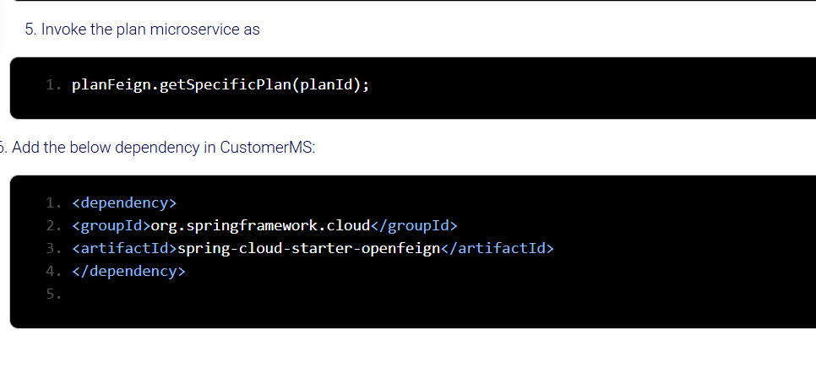

No need to use Loadbalanced Rest template to call the other microservice or to loadbalance them if feign client is used. Internally Feign client loadbalances the requests and helps calling other microservices.

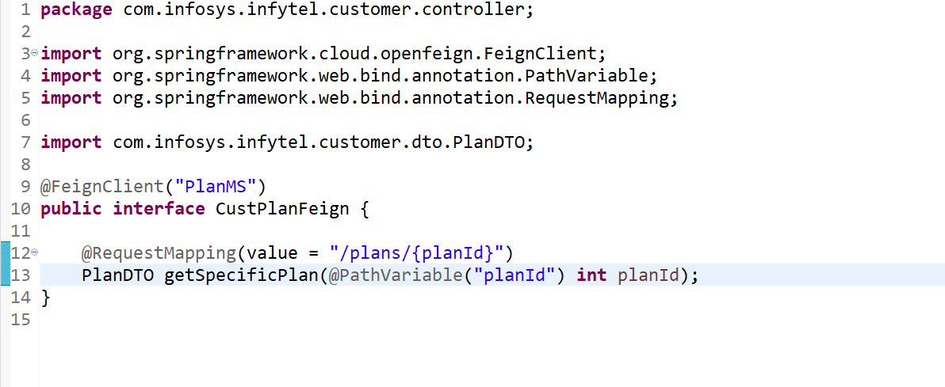

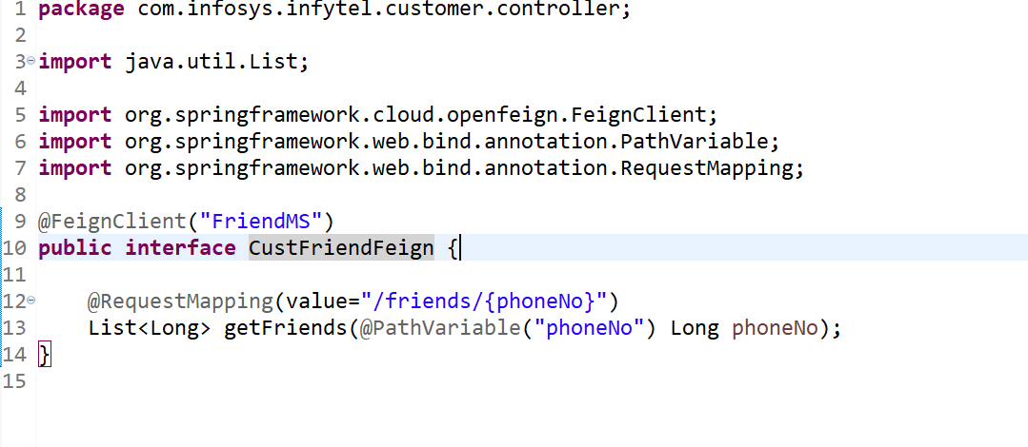

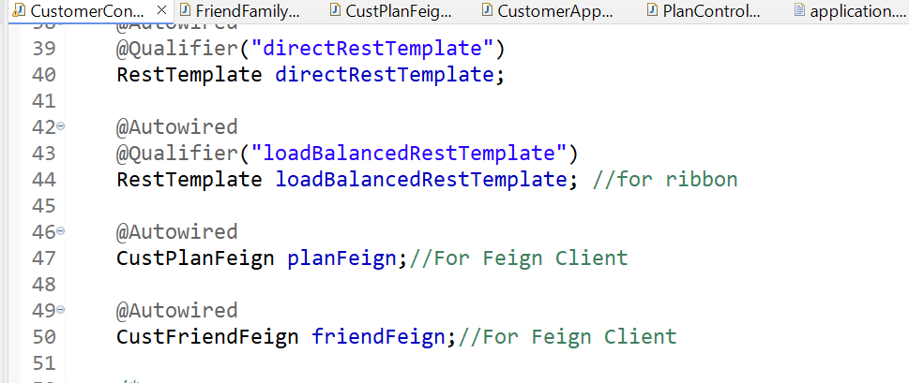

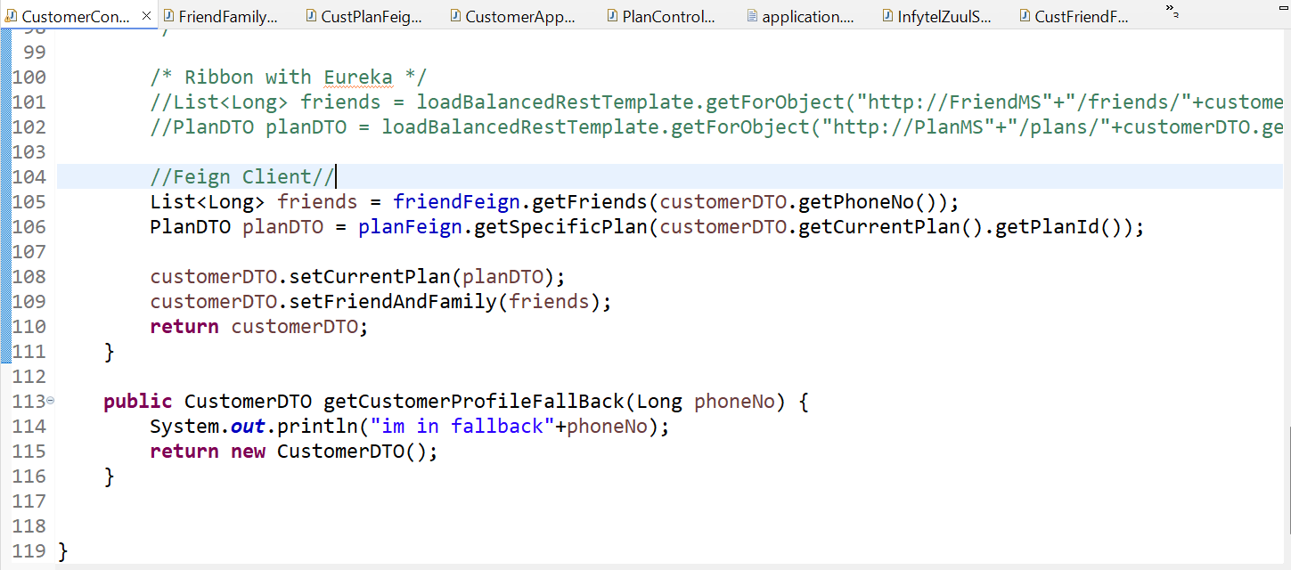

* Application.properties of ZuulServer to make rest calls through it.

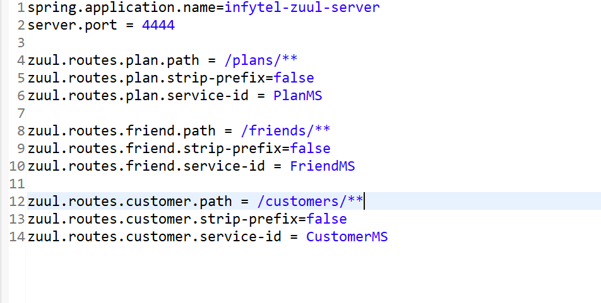

**Distributed Tracing and Monitoring (Zipkin, Sleuth, Prometheus, Grafana)**

**Centralized Logging (ELK Stack or EFK Stack)**

**Docker and Kubernetes**

**API Versioning and Documentation (Swagger / OpenAPI)**

**Asynchronous Communication with Message Brokers (Kafka / RabbitMQ)**